

**Defining a Knowledge Graph Development Process Through a Systematic Review**

GYT˙E TAMAŠAUSKAIT˙E, University of Amsterdam, Netherlands PAUL GROTH, University of Amsterdam, Netherlands

Knowledge graphs are widely used in industry and studied within the academic community. However, the models applied in the development of knowledge graphs vary. Analysing and providing a synthesis of the commonly used approaches to knowledge graph development would provide researchers and practitioners a better understanding of the overall process and methods involved. Hence, this paper aims to deine the overall process of knowledge graph development and its key constituent steps. For this purpose, a systematic review and a conceptual analysis of the literature was conducted. The resulting process was compared to case studies to evaluate its applicability. The proposed process suggests a uniied approach and provides guidance for both researchers and practitioners when constructing and managing knowledge graphs.

CCS Concepts: · **Software and its engineering** → **Software development process management**; · **Computing meth-odologies** → Ontology engineering; Semantic networks; · **Information systems** → Semantic web description languages; Information integration.

Additional Key Words and Phrases: knowledge graphs, knowledge graph construction, development process semantic network, information integration

**ACM Reference Format:**   
Gyt˙e Tamašauskait˙e and Paul Groth. 2022. Deining a Knowledge Graph Development Process Through a Systematic Review.

ACM Trans. Softw. Eng. Methodol. 1, 1 (April 2022), 40 pages. <https://doi.org/10.1145/3522586>

1 INTRODUCTION

Knowledge graphs ś graph-structured knowledge bases [57] ś are widely employed to represent structured knowledge and perform a variety of AI driven tasks in the context of diverse, dynamic and large-scale data [32, 87]. Given this increasing adoption, there is a need for guidance on knowledge graph development that would assist researchers, developers and engineers in the process of creating and maintaining knowledge graphs [9]. While there are descriptions of methods for knowledge graph development [37, 80], that outline the necessary steps to take in order to develop a knowledge graph, these methods vary per article and there is a lack of a global view of the development of these software artifacts.

While generally applicable development processes exist in such areas as software development [3], ontology construction [26] and knowledge engineering [64], it is unclear to what extent these existing theories can be directly applied to knowledge graph development, due to the complex combination of data and software used for their construction. Indeed, from a software engineering perspective knowledge graphs provide a fascinating area for study given their inherent combination of software, data and often human components.

Thus, considering the growth of knowledge graphs and a lack of global process view of their development, this paper focuses on formulating key process steps when managing the construction and maintenance of knowledge

Authors’ addresses: [Gyt˙e Tamašauskait˙e,](https://orcid.org/0000-0001-9033-4976) University of Amsterdam, Amsterdam, Netherlands, gyte.tama@gmail.coml; [Paul Groth,](https://orcid.org/0000-0003-0183-6910) University of Amsterdam, Amsterdam, Netherlands, p.t.groth@uva.nl.

Permission to make digital or hard copies of part or all of this work for personal or classroom use is granted without fee provided that copies are not made or distributed for proit or commercial advantage and that copies bear this notice and the full citation on the irst page. Copyrights for third-party components of this work must be honored. For all other uses, contact the owner/author(s).

© 2022 Copyright held by the owner/author(s).

1049-331X/2022/4-ART   
<https://doi.org/10.1145/3522586>

ACM Trans. Softw. Eng. Methodol., Vol. 1, No. 1, Article . Publication date: April 2022.

|  |  |  |
| --- | --- | --- |
| 2 | • | Tamašauskait˙e and Groth |

graphs. Speciically, this paper contributes a: a synthesis of common steps in knowledge graph development described in the academic literature. The aim is to provide guidance for both academia and industry in planning and managing the process of knowledge graph development. Moreover, we hope this analysis can provide for a better understanding of how other development lifecycles can be applied to knowledge graphs.

This paper is structured as follows: Section 2 covers related work in the area of knowledge graphs. Then, the methodology behind the systematic review is presented in Section 3. This is followed by the results of the review, in Section 4, which describe the proposed knowledge graph development process, its steps and how they interrelate. The process is assessed by mapping the proposed steps to the case studies in Section 5. Finally, Section 6 discusses the strengths and limitations of the research. Section 7 outlines the main indings and future work.

2 RELATED WORK

This section presents knowledge graphs, trends in their development and development practices more broadly.

2.1 Knowledge Graphs

The term "knowledge graph" was irst used in 1972, however, it became widely adopted after 2012, following the announcement of the Google Knowledge Graph [1, 29]. This event also led to the growth of the development and use of knowledge graphs in industry [27, 32, 58].

The term łknowledge graphž can be deined as "a graph of data intended to accumulate and convey knowledge of the real world, whose nodes represent entities of interest and whose edges represent relations between these entities" [32]. Thus, knowledge graphs are structured to represent facts that cover entities, relations and semantic descriptions [37]. Knowledge graphs can be formally deined as a directed graph (G), where



|  |  |  |  |  |
| --- | --- | --- | --- | --- |
| 2.2 | Trends in Knowledge Graph Development | Defining a Knowledge Graph Development Process | • | 3 |

Knowledge graph development is commonly categorised into two types, either as top-down or bottom-up [2, 23, 45, 92]. The top-down approach refers to when the ontology (or data schema) is deined irst and, based on the ontology, knowledge is extracted [45]. The bottom-up approach refers to when the knowledge is extracted from data and, based on the data, the ontology of the knowledge graph is deined [45].

Current research presents multiple instances of how knowledge graphs can be developed [37, 80, 87, 88]. How-ever, it commonly focuses on state-of-the-art techniques (e.g., machine learning and other advanced algorithms) that can be used in the development of knowledge graphs rather than the overall process of knowledge graph development.

For example, the techniques discussed in one study [87] include data extraction from various sources, harvesting relations between entities, building rules and inference, as well as storage and management of the knowledge graph. In another study [80], the techniques are grouped diferently Ð knowledge integration, entity discovery and typing, entity canonicalisation, construction of attributes and relationships, open schema construction and knowledge base curation. Yet, another study [88] focuses on the techniques of structured knowledge extraction, classiication and non-classiication relationship extraction, and graph optimisation. Thus, there are both diferent approaches to as well as diferent vocabularies used with respect to knowledge graph development.

Therefore, this paper focuses on reviewing diferent knowledge graph development processes presented in the literature. It contributes to the ield by providing a summary of how knowledge graphs are being constructed as well as providing a synthesized description of the process.

2.3 Applicability of Existing Development Processes

Similar processes of development are described in other areas of computer science, for example, in software engineering or ontology construction.

In software engineering, there are several development life cycles, e.g., waterfall, V-model, incremental, iterative and spiral [3]. While, in general, these life cycles could be applied when developing the knowledge graph, it is not known to what extent it could cover the speciic requirements of the knowledge graph development.

In ontology construction, there are also several approaches, such as the Cyc method, Uschold and King’s method, the Grüninger and Fox’s methodology, the KACTUS approach, METHONTOLOGY and others [26]. Ontologies and knowledge graphs have similarities, though, ontologies primarily focus on capturing the knowledge models (i.e. data models), while knowledge graphs primarily focus on capturing the large amounts of data itself [63]. Additionally, ontology construction is commonly seen as one of the steps in knowledge graph development [23, 92]. Thus, it is not apparent whether ontology construction methodologies are fully suitable for knowledge graph development.

While it is useful to understand these existing approaches, it is also beneicial to take into account the speciicity of knowledge graph development. Understanding how knowledge graphs are developed allows for better insights into how these existing approaches can be applied.

3 METHODOLOGY

To understand the overall process of knowledge graph development, we conducted a systematic review of the literature to understand the key process steps - identifying, describing and integrating these concepts. To evaluate the applicability of the process, we compared it to real-world case studies. The methodology was designed based on the principles for systematic reviews in software engineering [43] and the main phases of the conceptual framework analysis [35].

The following sections present the details of how the data collection and data analysis were conducted as well as the evaluation approach.

ACM Trans. Softw. Eng. Methodol., Vol. 1, No. 1, Article . Publication date: April 2022.

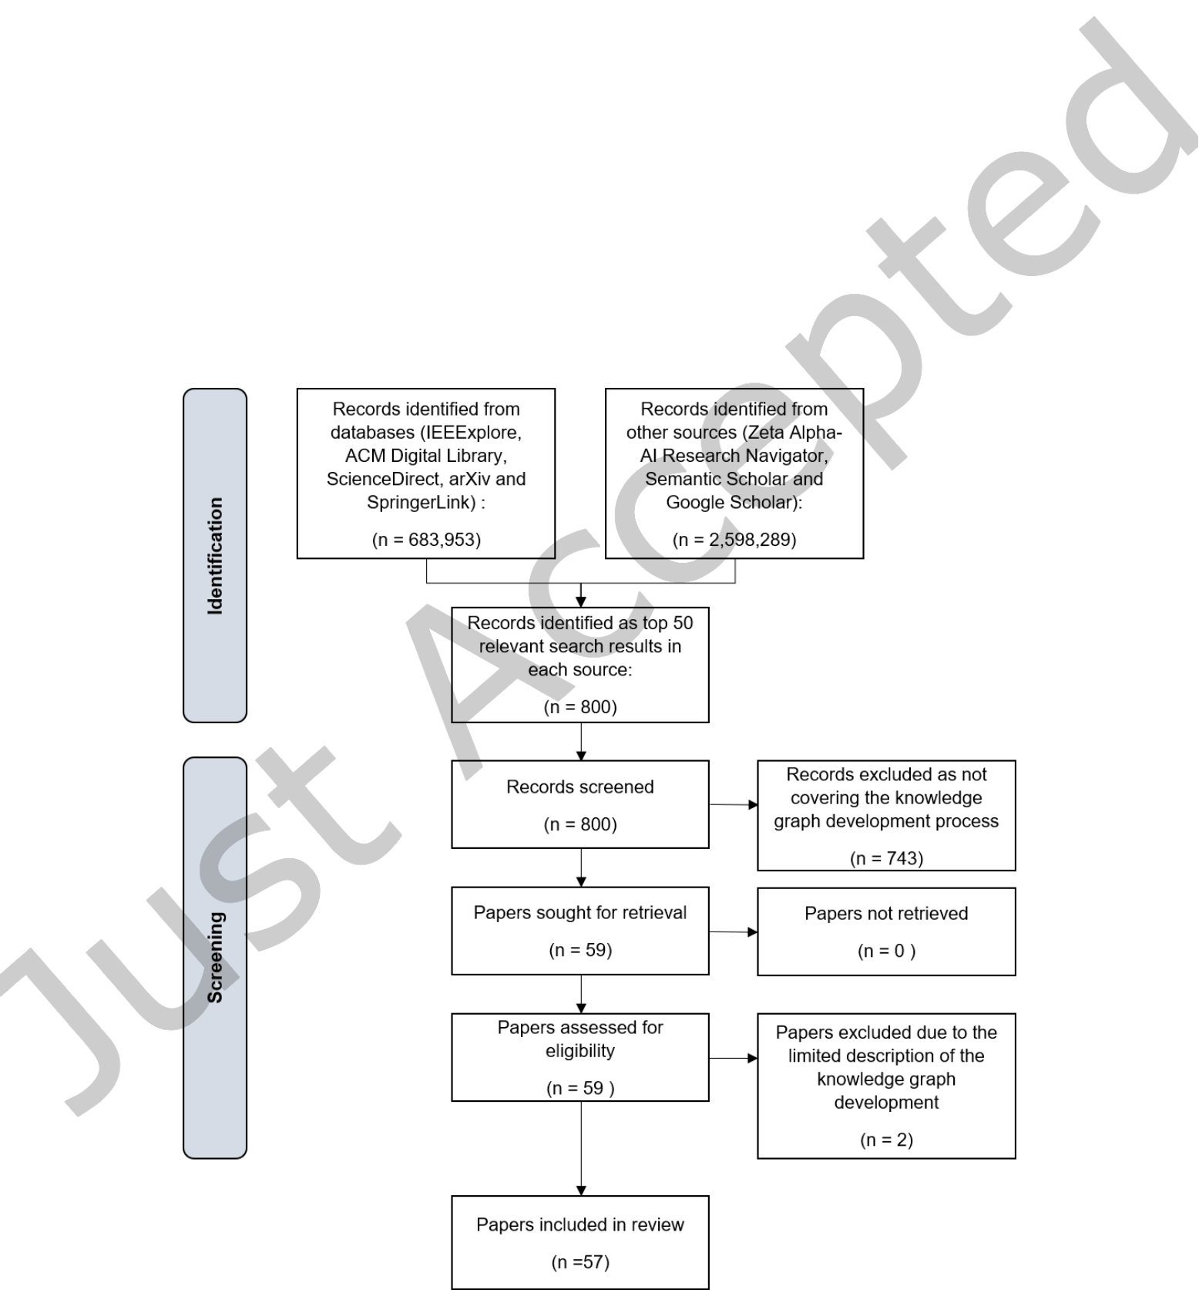

4 • Tamašauskait˙e and Groth

3.1 Data Collection

As a basis for this paper, relevant and recent research papers were collected and analysed. The overall low of selecting papers for the systematic review is presented in Figure 2 as a PRISMA worklow [60]. The data collection and screening was performed by a single author with checks in terms of protocol conducted by the other author.

Data sources. Papers were collected from eight online well-established data sources for academic research (ACM Digital Library, IEEExplore, ScienceDirect, arXiv, SpringerLink, Zeta Alpha-AI Research Navigator, Semantic Scholar and Google Scholar) within the period of March-April 2021. The majority of the sources are recommended in particular when performing software engineering reviews [43].

Inclusion and exclusion criteria. For the search, two keywords were used: knowledge graph development and knowledge graph construction. Only papers from 2012 onward were considered as the growth of the topic started in 2012 with the announcement of Google Knowledge Graph [32]. Only papers in English were reviewed. The irst most relevant (as determined by the data source’s ranking) 50 papers per source were screened, setting a threshold for prioritising the review of papers due to a large number of identiied papers and decreasing relevancy of search results [59].

Fig. 2. The PRISMA workflow of selecting papers for the systematic review

ACM Trans. Softw. Eng. Methodol., Vol. 1, No. 1, Article . Publication date: April 2022.



|  |  |  |
| --- | --- | --- |
| Defining a Knowledge Graph Development Process | • | 5 |

Table 1. Summary details of the selected papers

**Count of papers**   
**Year**

|  |  |
| --- | --- |
| 2016  2017  2018  2019  2020  2021 | 1  5  10  11  24  6 |

**Type of paper**

|  |  |
| --- | --- |
| Domain-speciic Methodological | 47  10 |

**Type of KG development**

|  |  |
| --- | --- |
| Bottom-up  Top-down | 41  16 |

First, the title and abstract were screened to determine whether the article covers the knowledge graph development. Then, the content of the paper was skimmed to assess if it covers the explicit process steps. If the paper met these criteria, it was added to the reference management system for further analysis.

Considering that the papers were chosen from credible sources and that the papers focused on knowledge graphs as a result, rather than relecting on its development process, the evaluation of the experimental results of the papers was not performed.

Search outcome. Overall, 57 articles were selected for the analysis ranging from 2016 to 20211(the full list is in Appendix A), that given focused time period ensures that the totality of relevant articles are covered. The distribution of the year of publication is presented in Table 1.

The majority of the papers were covering the development of domain-speciic knowledge graphs (Table 1). These papers focus on presenting knowledge graphs built for a speciic purpose and what techniques were used for their development. Another type of paper was categorised as methodological, presenting a more theoretical overview of knowledge graphs and development methods.

Furthermore, the majority of articles covered bottom-up knowledge graph development approach (Table 1). Although the majority of papers do not indicate the type of the development approach used, the distinction was made by determining whether the ontology development was done or not as the irst step of knowledge graph development.

After having selected the papers, the required data was extracted from the papers and analysed in multiple iterations. As a irst iteration, the type of the paper, the type of the knowledge graph development process and the process itself were written down. Then, an extensive list of the process’ steps was compiled.

The processes were of diferent granularity, some including the algorithms and techniques used in the know-ledge graph construction as steps, while others only indicated the main phases. The process steps were written out in three diferent levels, specifying the more generic steps and what they consist of (see Figure 3). Level I steps provide a more generic description of the step, Level II steps specify Level I tasks into smaller stages, while Level III steps are speciic and focus on describing the algorithms and techniques used.

1Note that during screening no relevant articles from 2012 to 2016 were identiied and, thus, not included in this review. While there are a number of articles on knowledge graphs in 2012-2016, the main focus of these articles is on technological or theoretical analysis of knowledge instead of presenting the development process.

ACM Trans. Softw. Eng. Methodol., Vol. 1, No. 1, Article . Publication date: April 2022.

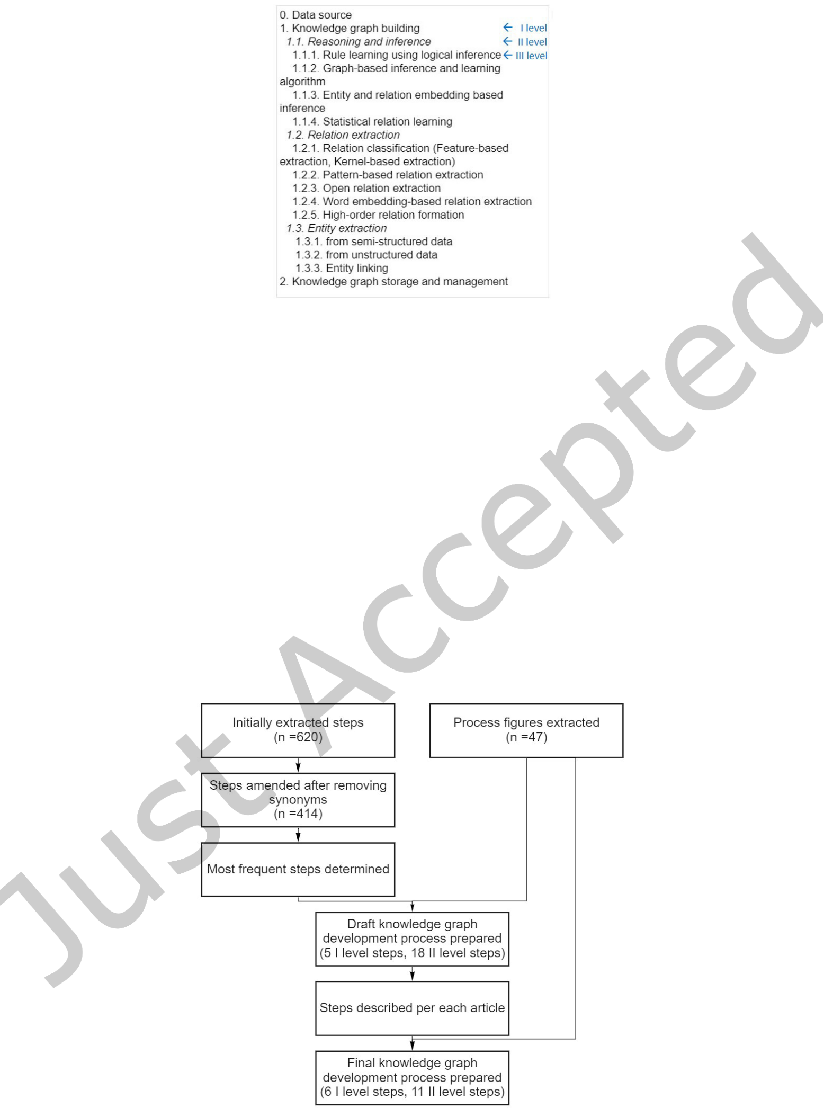

|  |  |  |
| --- | --- | --- |
| 6 | • | Tamašauskait˙e and Groth |

Fig. 3. Example of recorded process steps from [87]

3.2 Data Analysis

The overall data analysis worklow is presented in Figure 4 that describes how steps of knowledge graph development were extracted and processed.

Initially, a total of 620 steps of all levels were indicated, of which 519 steps were unique. However, some steps were synonymous to each other, thus, the list was manually amended by changing similar tasks to the same expressions, e.g. relationship extraction was changed to relation extraction; data, data input and similar were changed to data source. After adjusting the synonyms, there were 414 unique values in the inal list, of which 182 were of level I, 196 of level II and 60 of level III. The III level steps were speciic, indicating the algorithms

Fig. 4. Workflow of data analysis

ACM Trans. Softw. Eng. Methodol., Vol. 1, No. 1, Article . Publication date: April 2022.

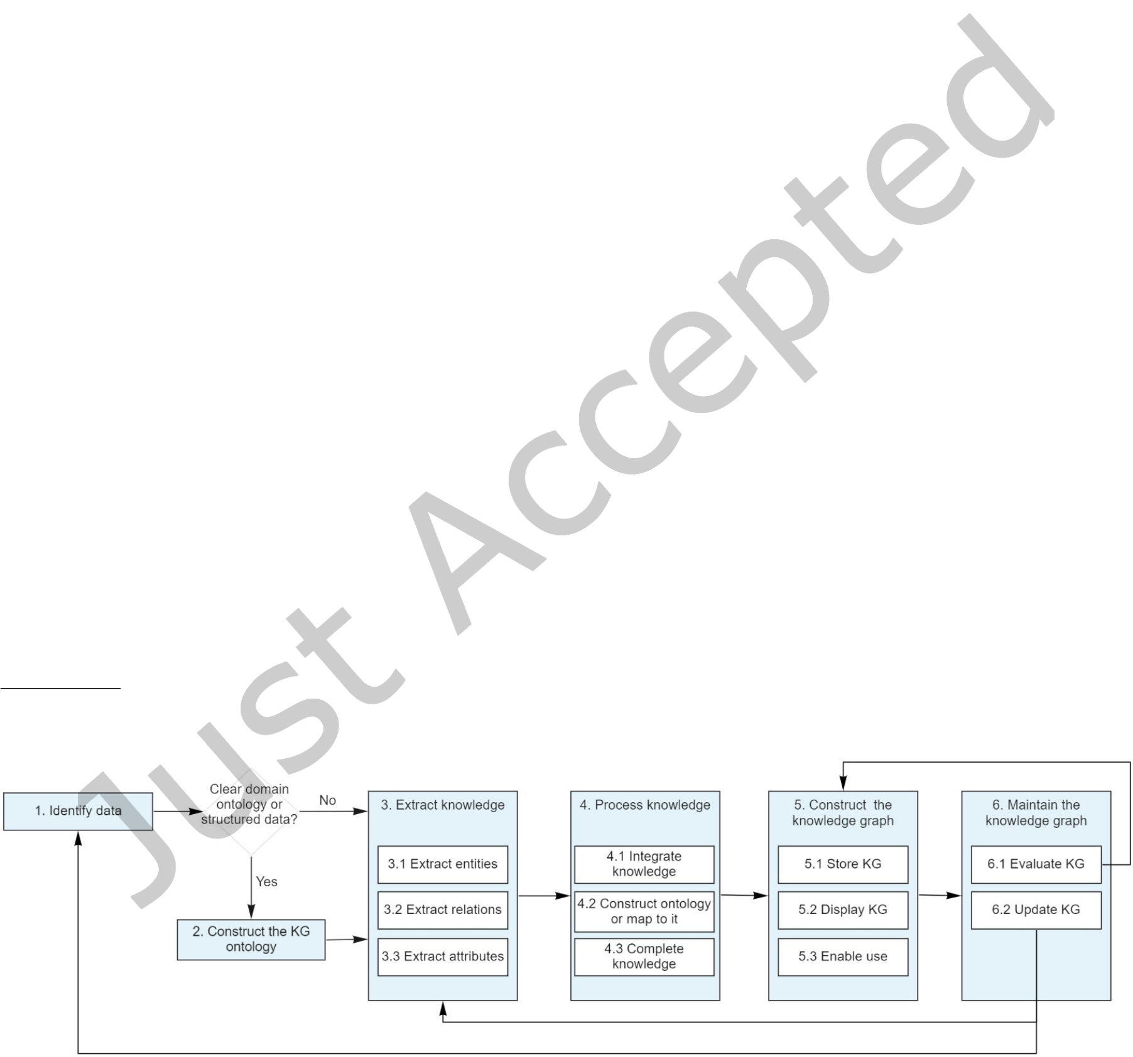

|  |  |  |
| --- | --- | --- |
| Defining a Knowledge Graph Development Process | • | 7 |

and techniques used, thus, were not considered in further analysis. The full list of process steps is available in a dataset repository2.

The frequency of each step was counted to determine the most common steps in the knowledge graph development. This was used as guidance in formulating the general process steps. Additionally, the process igures were extracted from each paper, which allowed analysis of how the process is presented visually (Appendix C and dataset repository).

Using information about frequent steps and the visually presented processes, the irst process draft of the knowledge graph development was prepared. Then, having these steps, each paper was reviewed again in order to record the relevant data per each indicated process step.

Finally, using the described steps of the knowledge graph development process and the visual representations of the processes, the inal proposed process was developed and is described in more detail in the following section.

3.3 Evaluation through Case Studies

In order to evaluate the applicability and generalisability of the proposed knowledge graph development process, a comparison to case studies was carried out. The proposed process was compared and mapped to real-life knowledge graphs and how they are constructed and maintained. The evaluation covers the comparison of two types of knowledge graphs Ð generic open knowledge graphs and domain-speciic knowledge graphs. As a result, this evaluation provided insights on to what extent the proposed process is suitable and relevant to real life examples, as well as possible areas for future work with respect to development lifecycles.

4 RESULTS

The knowledge graph development process based on the review and analysis of the selected articles is presented in Figure 5. The process consists of six main steps: (i) Identify data, (ii) Construct the knowledge graph ontology, (iii) Extract knowledge, (iv) Process knowledge, (v) Construct the knowledge graph, and (vi) Maintain the knowledge graph. The process incorporates both top-down and bottom-up approaches. Each step and its sub-steps are described in the following sections.

4.1 Identify Data

The objective of this step is to identify a domain of interest, a data source and a way of data acquisition. As mentioned before, knowledge graphs can either be generic or domain-speciic [2, 32]. Usually, generic knowledge graphs cover multiple domains and are publicly available, while domain-speciic knowledge graphs are for

2<https://zenodo.org/record/5608878>

Fig. 5. The proposed knowledge graph development process

ACM Trans. Softw. Eng. Methodol., Vol. 1, No. 1, Article . Publication date: April 2022.



|  |  |  |
| --- | --- | --- |
| 8 | • | Tamašauskait˙e and Groth |

speciic domain or problem and commonly used in organisations for their operations. Deining the domain of the knowledge graph allows for better identiication of data sources and determine how data can be extracted later [87]. The domain can be as broad or narrow as needed, e.g., education [4, 6, 13, 16, 18, 67, 69, 90], healthcare [34, 47, 52, 78], social media [48, 66], etc.

Having chosen the domain, it is important to identify the data sources as it inluences the overall knowledge graph development process as well as the choice of knowledge extraction techniques. In general, data can be either structured, semi-structured or unstructured, and can be extracted from multiple sources. Structured data is a type of data that has explicit structure, e.g., data in tables or relational databases [82]. Semi-structured data has a certain structure but it is not strict, e.g., XML data [82]. Unstructured data does not have a predeined structure, e.g., text [82]. For instance, data can be acquired from an online encyclopedia such as Wikipedia (e.g., [28, 83]), a structured database (e.g., [16]), semi-structured documents (e.g., [90]), unstructured text (e.g., [21]) or a mix of several data sources (e.g., [86]).

Finally, the data acquisition methods are chosen based on the type of data and data source. Web resources can be acquired using web crawlers (e.g., [14]), databases can be harvested using data mining techniques (e.g., [85]), iles can be downloaded or accessed directly (e.g. [70]). A suitable method should be chosen considering what data is needed for constructing a knowledge graph.

As the result of this step, the data required for knowledge graph development is acquired and prepared for the knowledge extraction.

4.2 Construct the Knowledge Graph Ontology

The objective of this step is to construct the knowledge graph ontology that provides a top-level structure for the knowledge graph. This step is needed when the top-down approach is used. The top-down approach is usually used either when (i) there is already a clear domain ontology (e.g. medical classiication in a healthcare domain [52]) that can be used as a basis for the knowledge graph ontology, or (ii) there is structured data that provides a framework for the ontology to be constructed (e.g. a course syllabus structure in an education domain [6]). Constructing the knowledge graph ontology allows having predeined types of entities and relations between them. For the basis of ontology construction, common ontologies such as FOAF [11], Geonames [81] or others relevant for the domain, as well as common ontology languages such as RDF(S) [73], OWL [72] and XML [74] can be reused.

Ontologies can be constructed manually or automatically. Domain experts can manually develop the ontology, but it is labour intensive. Additionally, it may be complicated to ind relevant experts if the domain is narrow [45]. The automatic approach is driven by data and is described in Step 4.2 (see Section 4.4.2).

4.3 Extract Knowledge

Having acquired the data, the next step is to extract knowledge from it. The objective of this step is to extract entities, relations between them and attributes. There are a number of methods to apply for knowledge extraction, and for diferent types of data, diferent techniques are needed. Knowledge extraction from semi-structured and unstructured data requires more efort and more complex techniques, while for structured data, entities and relationships are identiied more easily.

4.3.1 Extract entities. Entity extraction is aimed to discover and detect entities in a wide range of data. The objective of this step is both to discover multiple entities for a given type and to identify more informative types for a certain entity [80]. One of the most frequently applied methods is named-entity recognition (NER), which focuses on the discovery and classiication of entities to the predeined categories or types [14, 34, 36, 38, 40, 47, 48, 51, 53, 69, 84, 86, 87, 92]. Other machine learning methods also include dictionary-based or pattern-based discovery, sequence labelling, word and entity embeddings, etc. [80].

ACM Trans. Softw. Eng. Methodol., Vol. 1, No. 1, Article . Publication date: April 2022.



|  |  |  |
| --- | --- | --- |
| Defining a Knowledge Graph Development Process | • | 9 |

The quality of extracted entities highly afects the eiciency and quality of knowledge extraction tasks (relations, attributes). Thus, it is a crucial step in knowledge graph development [92].

4.3.2 Extract relations. After having extracted entities, they are isolated and not linked together, therefore, it is necessary to extract relations among the entities as well [38]. This step also depends on the type of data. For structured data, relations are explicit and easily identiiable. For semi-structured data, the pattern-based and rule-based approaches can be used as well as other machine learning techniques [80, 87]. In case of unstructured, textual data, relation extraction requires interpreting semantic information, where natural language processing (NLP) methods are commonly used [14, 38, 84], such as semantic role labeling [21, 54, 66, 87] or neural information extraction [80, 87]. Other examples of relation extraction methods include Open Information Extraction (OIE), bootstrapping and distant supervision for automatic labelling, methods based on frame semantics, such as FrameNet [32], kernel methods and word embeddings [87]. If an ontology is available (as deined in Step 2, Section 4.2), then the relations between extracted entities can be assigned based on the ones deined in the ontology [78].

As a result of this step, having extracted entities and relations allows constructing triples that are used in the knowledge graph.

4.3.3 Extract atributes. Attribute extraction refers to acquiring and aggregating the information about a speciic entity [48, 51]. In some cases, attribute extraction is seen as the discovery of special types of relations [48] between entities. Nevertheless, the main objective of this step is to describe the entity more clearly [92].

For attribute extraction, similar methods to ones used for relation extraction can be applied, e.g. semantic role labeling [54], or machine learning techniques [80]. In some cases, the type of attribute can be predeined before extracting or gathering the data, e.g., attributes for road signs are colour, shape, etc. [42].

4.4 Process Knowledge

The next step in the process is the processing of knowledge. The objective of this step is to ensure that the knowledge extracted is of high quality. The unprocessed extracted entities, relations and attributes may be ambiguous, redundant or incomplete. Furthermore, knowledge from diferent sources has to be aligned. Therefore, it is needed to integrate the knowledge, map it to an ontology and complete missing values before constructing the knowledge graph.

4.4.1 Integrate knowledge. Knowledge integration, also known as knowledge fusion, refers to integrating know-ledge from diferent sources and cleaning it to eliminate redundancy, contradiction, and ambiguity [45, 48, 62].

First of all, all knowledge should be cleaned by removing unnecessary signs, stop words and other noise, if there is any [19]. This improves the overall quality of knowledge and prepares the data for entity resolution.

In order to remove duplicates and eliminate ambiguity, it is necessary to perform entity resolution [40, 92] that is also referred to as entity alignment [51, 84, 92], entity canonicalisation [80] and entity matching [38, 92]. The objective of this task is to evaluate if diferent entities refer to the same real-world objects, and, if so, link them in the knowledge graph. Furthermore, all entities should be linked to unique identiiers (such as URI or IRI) that allow the deinition of custom namespaces [55].

Entity resolution involves the tasks of blocking, that is used to cluster similar entities to the blocks, and similarity, that is used to evaluate are there are duplicates in the block [40]. There are a variety of methods to be applied per each task, including traditional blocking, sorted neighbourhoods, canopies for blocking and machine learning methods for similarity, such as feature vector computation and others [40].

Relations can also be semantically similar, but syntactically diferent, thus, it is also necessary to merge similar relations and only keep the main ones (e.g, exploit, use, and adopt are similar [19]).

ACM Trans. Softw. Eng. Methodol., Vol. 1, No. 1, Article . Publication date: April 2022.



10 • Tamašauskait˙e and Groth

4.4.2 Construct ontology or map to it. If the ontology was not constructed in Step 2 (Section 4.2), then it is recommended to develop it after having integrated knowledge. The ontology in Step 2 deines the structure of the knowledge graph before extracting knowledge, whereas, in this step, the structure of the knowledge graph is deined based on the extracted knowledge.

The ontology of a knowledge graph allows creating a model of how the knowledge graph is represented in a structured way [23] and describes relations between concepts within a domain [33]. It also helps to evaluate the quality of the extracted data and how completed the knowledge is. While constructing the ontology, it is possible to analyse the knowledge graph and identify if the use of domain knowledge is not redundant [70] or predict incomplete ontological triples [36]. Moreover, the construction of the ontology should follow good practices of ontology development [10].

If the ontology was developed in Step 2 and additional knowledge was extracted in Step 3 (Section 4.3), then at this step mapping between the ontology and the extracted knowledge should be done. Thereby, the types of entities and relations should be aligned to the ones deined in the ontology [78]. Additionally, the previously developed ontology can be enriched based on the extracted knowledge [28]. Thus, the ontology of the knowledge graph should be continuously reviewed and updated.

4.4.3 Complete knowledge. The objective of this step is to complete and enrich the knowledge in the knowledge graph as well as to improve its overall quality. This includes performing reasoning and inference, validating the triples and optimising the knowledge graph.

Knowledge reasoning and inference refers to developing and enriching the knowledge graph by establishing new relations among entities based on existing relations and discovering new knowledge from existing knowledge [48, 77]. In general, this can be done by logical inference that is based on the existing rules between relations; and through the use of machine learning (e.g. statistical relational learning or building embedding based link predictors and node classiiers) [61, 87]. The latter notion also comes under the heading of knowledge graph reinement [61].

The validation of triples allows ensuring that only valid and relevant knowledge is included in the knowledge graph. This can be done by setting integrity and other constraints [23] or setting necessary features for a triple to be considered valid [21]. In addition, a labelling process can be applied to tag triples as valid or not valid [19].

Finally, knowledge graph optimisation can be performed by removing nodes that are not relevant to the domain [88]. This should be based on consistent and logical rules that allow identifying and eliminating conlicts and gaps in the knowledge graph [80].

4.5 Construct the Knowledge Graph

The objective of this step is to ensure that the knowledge graph is accessible and available for use. This includes storing the knowledge graph in a suitable database, displaying and visualising it for exploration, as well as enabling its use.

4.5.1 Store knowledge graph. The knowledge graphs can be stored in various ways due to a wide variety of data models, graph algorithms, and applications [87]. This includes relational databases, key/value stores, triple stores, map/reduce storage [87] and graph databases [32].

Relational databases can be used for storage, even though they may not be the most suitable for large graph management [87]. This type of database can be implemented on top of an existing relational database in the organisation’s infrastructure [77, 87].

Key/value stores are NoSQL database systems that allow improving scalability of knowledge graphs and more lexibility with regard to data types [87].

ACM Trans. Softw. Eng. Methodol., Vol. 1, No. 1, Article . Publication date: April 2022.

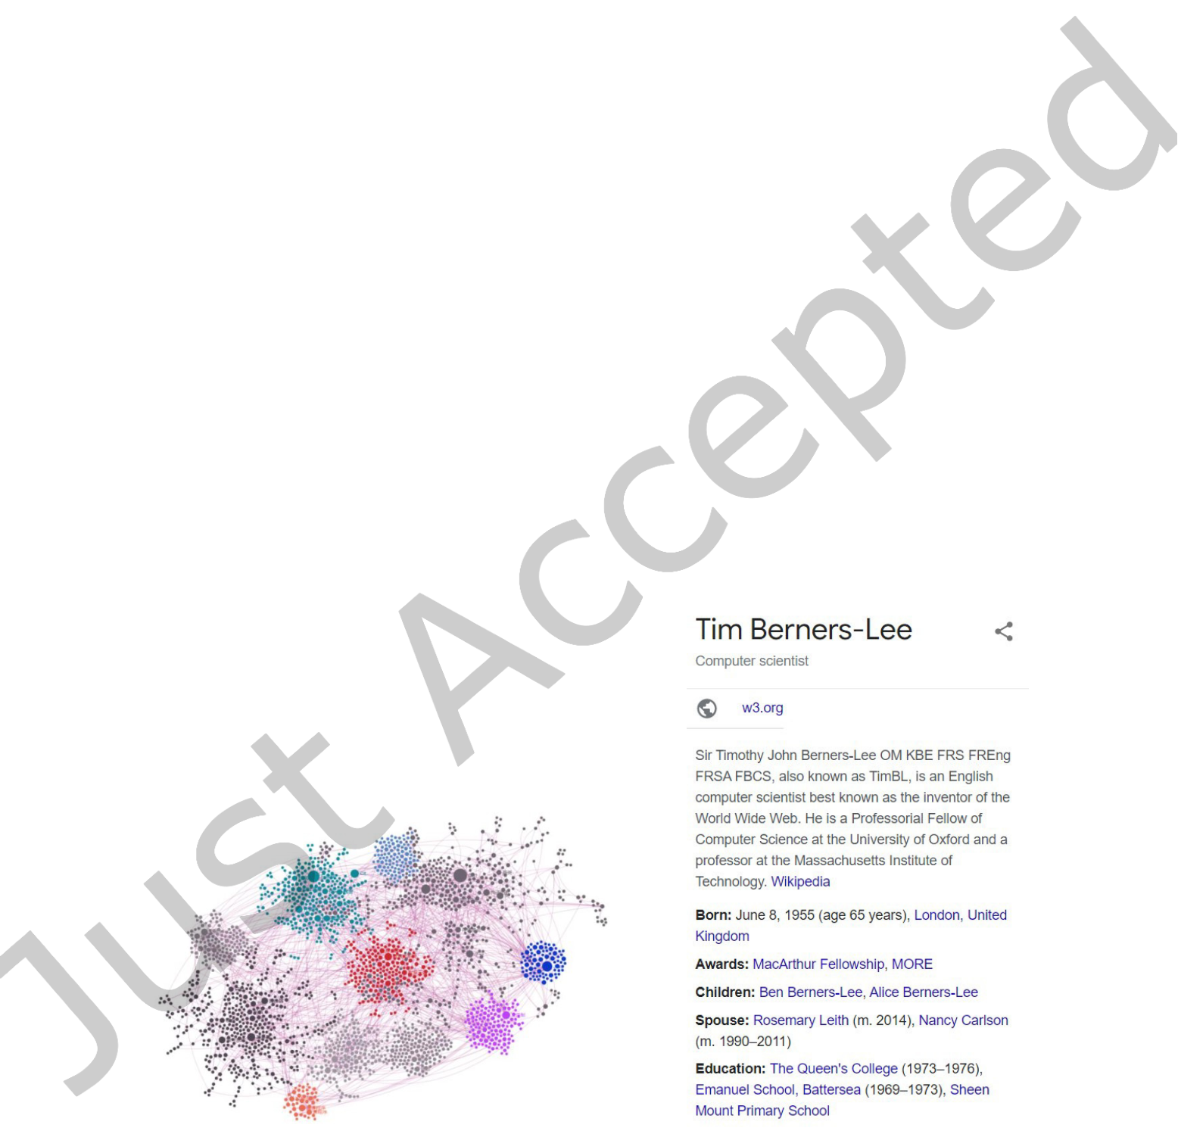

|  |  |  |
| --- | --- | --- |
| Defining a Knowledge Graph Development Process | • | 11 |

Triple stores are databases that store knowledge as triples (subject - predicate - object). The majority of triple stores focus on storing knowledge graphs as RDF triples that provide a uniied framework for representing information online [87].

Map/reduce storage is used for processing large knowledge graphs as it divides the number of nodes on diferent machines, then each machine requires a relatively small size of computation [87].

Graph databases allow for the storage of nodes, edges and properties of graphs. These databases provide a variety of functionalities for querying and graph mining, however, the update of knowledge can be slow [92]. As an example of a graph database, Neo4j is widely used in the knowledge graph development [14, 15, 22, 33, 38, 49, 51, 53, 56, 70, 86, 88, 90]. It has built-in functionality for, among other things, graph analysis and querying [22, 53].

4.5.2 Display knowledge graph. Knowledge graphs are useful because they can be not only analysed in the database but also inspected visually. For this, it is necessary to create a knowledge graph visualisation in order to enable analysis, navigation and discovery of related knowledge [40, 69, 75, 78, 92]. An example of knowledge graph visualisation is presented in Figure 6a.

Some knowledge graph databases have built-in tools for graph visualisation, for example, Neo4j [56]. Another option is to develop the visualisation using front-end tech stacks, for example, using suitable JavaScript libraries [33, 51, 54, 67, 69]. When developing knowledge graph visualisations, it is important to ensure interactivity and follow best practices of information visualisation.

Nevertheless, the display of the visualisation depends on the application of the knowledge graph. For example, Google presents the nodes of Google Knowledge Graph as infoboxes in the search results (Figure 6b). Thus, the knowledge graphs can be displayed in multiple ways and the most suitable one should be chosen considering the intended use of the graph.

(a) Example of a knowledge graph visualisa-tion as a network [67]

(b) Example of the Google in-fobox for Tim Burners-Lee.

Fig. 6. Examples of knowledge graph visualisations

ACM Trans. Softw. Eng. Methodol., Vol. 1, No. 1, Article . Publication date: April 2022.



12 • Tamašauskait˙e and Groth

4.5.3 Enable use. Knowledge graphs can have multiple applications, such as web search [87], question answering [78], recommendation generation [46], chatbot functionalities [46], decision support systems [47], text under-standing [80, 87], etc. The application depends on the purpose of the knowledge graph and the domain. Regardless of the chosen application, it is then necessary to implement tools that enable efective knowledge graph use. The implementation is highly dependent on the required functionality. Furthermore, it is important to consider the end users, what kind of skills they have and how they are going to use the knowledge graph.

Querying is one of the key functions of knowledge graphs. It allows users to explore and discover knowledge. Query functions can be already built-in in the graph database [90]. For example, Neo4j supports the Cypher graph query language that allows data queries [70]. Other RDF triple stores support SPARQL, which is widely used as the standard query language of knowledge graphs [23, 92]. Querying functionality can also be developed based on speciic needs, for example, using knowledge graph matching, distributional semantic matching or other techniques [78].

4.6 Maintain the Knowledge Graph

As knowledge is constantly changing and evolving, knowledge graphs are never complete. Thus, it is necessary to constantly monitor the knowledge graph, its usage and data sources relevant for the domain and update the knowledge graphs as needed.

4.6.1 Evaluate the knowledge graph. Besides the evaluation of completeness and quality, which are addressed in Step 4 (Section 4.4), knowledge graphs can be tested through their application by gathering user feedback [91]. By analysing feedback, it is possible to identify gaps in the knowledge graph and set the development directions. This feedback may help identify new data available or provide suggestions on how to improve the application of the knowledge graph, e.g. make it faster or add new functionalities. For this, Step 5 (Section 4.5) has to be repeated by evaluating possible improvement in storage, display and/or use of the knowledge graph.

4.6.2 Update the knowledge graph. In general, updating the knowledge graph may be needed when (i) there is new data in the data source already used, or (ii) there is a new data source relevant for the knowledge domain [23].

To identify new data in the data source, version and update management is needed both in the data source and in the knowledge graph. Comparing the version and the latest date of update allows easy identiication of newly available data. However, this is not always possible, as not all data has version management. In particular, it may be more diicult with unstructured, free text data. Thus, other update mechanisms should be introduced, such as periodical extraction of new knowledge and mapping with current entities and relations [82]. Once new data is identiied, the process is repeated from Step 3 (Section 4.3).

The discovery of new relevant data sources is a more complex task. It requires manual research to identify and access new data sources, it can also include legal agreements for data use [23]. Once the new data source is identiied, the process is repeated from Step 1 (Section 4.1).

5 CASE STUDIES

In order to evaluate the applicability of the proposed knowledge graph development process, the process is compared to the development of two knowledge graphs Ð DBpedia as a generic open knowledge graph and the User Experience Practices Knowledge Graph as a domain-speciic knowledge graph.

5.1 Comparison to DBpedia

DBpedia is a crowd-sourced open knowledge graph project aimed to extract structured content from the Wikimedia projects [44]. Data is accessible as Linked Data and through standard Web browsers or automated crawlers.

ACM Trans. Softw. Eng. Methodol., Vol. 1, No. 1, Article . Publication date: April 2022.



|  |  |  |
| --- | --- | --- |
| Defining a Knowledge Graph Development Process | • | 13 |

DBpedia’s development process includes the following steps [20]:

(1) Deinition of mappings and ontology editing;   
(2) Execution of the knowledge extraction process over Wikipedia dumps; (3) Parsing and validation of the data against strict rules;   
(4) Release of (intermediate) data artifacts;   
(5) ID management and knowledge fusion from all language editions; (6) Deployment of the resulting knowledge graph.

The steps of the proposed knowledge graph development process can be mapped to the DBpedia process as follows:

(1) Identify data. This step is omitted in DBpedia’s development process as the data source is already identiied and clearly deined. As mentioned, DBpedia uses data from various Wikimedia projects. This covers a wide variety of domains, thus, making DBpedia a generic knowledge graph.

(2) Construct knowledge graph ontology. This step corresponds to the step "Deinition of mappings and ontology editing". DBpedia’s ontology was irst developed based on infoboxes within Wikipedia and is continuously updated [44]. Currently, the ontology has over 700 classes and 3000 properties [20].

(3) Extract knowledge. This step corresponds to the step "Execution of the knowledge extraction process over Wikipedia dumps". DBpedia extracts data from Wiki pages through the continuous knowledge extraction process (that is deined by DBpedia Information Extraction Framework (DIEF)) and live extraction, including entities, relations and attributes extraction. The continuous extraction is performed every month.

DBpedia extraction is available through mapping-based (rule-based), generic (automatic), text and Wikidata extraction [20].

(3.1) Extract entities. A key method of entity extraction in DBpedia is to extract unmapped information in Wikipedia infoboxes and create entities from the attribute values [20, 44].

(3.2) Extract relations. Mappings-based extraction is one of the methods used to extract relations from Wikipedia infoboxes [20].

(3.3) Extract attributes. Other attributes are extracted directly from the article text. Attributes then can be mapped to the existing properties [20].

(4) Process knowledge. This step corresponds to the steps "Parsing and validation of the data against strict rules" and "ID management and knowledge fusion from all language editions".

(4.1) Integrate knowledge. At irst, the data itself is parsed and validated for early release. Then, it is processed globally, focusing on eliminating redundancy and instability of IRI identiiers. For this process, DBpedia is using FlexiFusion approach that provides lexibility in processing a large variety of data[20].

(4.2) Construct ontology or map to it. The knowledge is mapped to DBpedia’s ontology [20]. This also allows for the evaluation of the completeness of the extracted knowledge.

(4.3) Complete knowledge. Finally, there are multiple data validation and quality rules applied to ensure the completeness of the RDF triples, for example, reviewing conformance to the predeined schema and ontology restrictions as well as identifying missing artifacts [30].

(5) Construct knowledge graph. This step corresponds to the steps "Release of (intermediate) data artifacts" and "Deployment of the resulting knowledge graph". The extracted and processed knowledge is published in an accessible way enabling its use twice Ð irstly, as intermediate data after strict parsing and validation, and secondly, as a completed knowledge graph [20].

(5.1) Store the knowledge graph. The data itself is stored in the DBpedia Databus platform.

(5.2) Display the knowledge graph. The Databus platform is accessible online as datasets, also, DBpedia Live can be accessed as an API. DBpedia also exposes human readable representations (i.e. HTML pages) of its knowledge in the form of Linked Data [44]

ACM Trans. Softw. Eng. Methodol., Vol. 1, No. 1, Article . Publication date: April 2022.

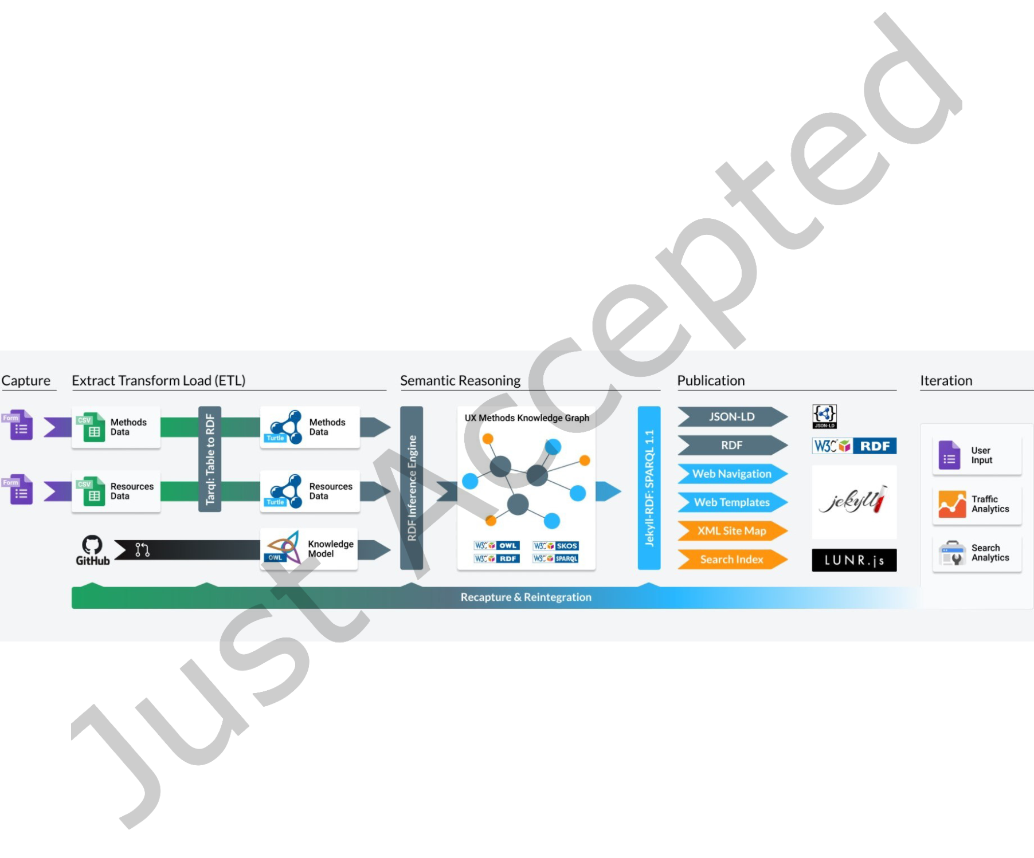

|  |  |  |
| --- | --- | --- |
| 14 | • | Tamašauskait˙e and Groth |

(5.3) Enable use. Data search is enabled by the DBpedia SPARQL endpoint as well through Linked Data [44]. This allows to users access data and use it for their own needs.

(6) Maintain knowledge graph. The entire process of DBpedia’s development is iterative and constantly reviewed which allows capturing the most recent and relevant data. This structured release cycle allows to ensure that the knowledge graph is kept up to date [30].

(6.1) Evaluate the knowledge graph. Community reviews, contributions and feedback are used to further develop DBpedia. The knowledge graph and its ontology is widely accessible for users to provide feedback and their suggestions on how the data should be updated [20, 44].

(6.2) Update the knowledge graph. As the DBpedia is based on Wikpedia data that is constantly changing and updated, DBpedia is also always maintained and updated version is updated in accordance to the release cycle [30].

Overall, DBpedia’s process is similar to the proposed one. Nevertheless, DBpedia’s process steps are speciied to better correspond to the operations and procedures as they are executed in DBpedia. In addition, DBpedia has two stages of processing and releasing data, which allows earlier access to data, even if it is not completed as a knowledge graph.

5.2 Comparison to User Experience Practices Knowledge Graph

UX Methods is a domain-speciic boutique knowledge graph aimed to gather and integrate knowledge related to the user experience design [25].3Its development worklow is presented in Figure 7 and consists of 5 main stages- (i) Capture, (ii) Extract Transform Load (ETL), (iii) Semantic Reasoning, (iv) Publication, (v) Iteration.

Fig. 7. The workflow of the UX Methods Knowledge Graph [24]

The steps of the proposed knowledge graph development process can be mapped to the UX Methods process as follows:

(1) Identify data. This step corresponds to the step "Capture". The data is submitted by users using Google Forms in a semi-structured way, providing such information as the method name, description, steps, outcomes, subsequent methods and available web resources. [25]. Additionally, a headless content management system is used to capture information.

(2) Construct the knowledge graph ontology. As the ontology of UX Methods is predeined, this step is omitted in the overall worklow. However, the UX Methods uses ontology to describe relationships between diferent disciplines and methods. It is constantly evolving as new knowledge is added [25].

3<https://github.com/andybywire/ux-methods>

ACM Trans. Softw. Eng. Methodol., Vol. 1, No. 1, Article . Publication date: April 2022.



|  |  |  |
| --- | --- | --- |
| Defining a Knowledge Graph Development Process | • | 15 |

(3) Extract knowledge. This step corresponds to the step "Extract Transform Load (ETL)". The manually captured data is extracted and transformed to RDF, including entities, relations and attributes. For this purpose, diferent techniques are used, including auto-classiication, semantic data integration and natural language processing [24].

(3.1) Extract entities. Entities are gathered through a headless content management system.

(3.2) Extract relations. The knowledge model provides a set of relation types that are then used to create relations between entities.

(3.3) Extract attributes. Attributes are also gathered through the headless content management system and mapped to the Knowledge Model.

(4) Process knowledge. This step corresponds to the steps "Extract Transform Load (ETL)" and "Semantic Reasoning".

(4.1) Integrate knowledge. Newly extracted knowledge can be linked to the existing entities when the data is being updated, however, this is not explicitly explained as the data is manually gathered.

(4.2) Construct ontology or map to it. The extracted knowledge is mapped to the ontology.

(4.3) Complete knowledge. The data is processed by Protégé reasoner that allows for enabling the inference and identifying additional relations, and thus, complete the knowledge graph [24].

(5) Construct knowledge graph. This step corresponds to the step "Publication" [25].

(5.1) Store the knowledge graph. The data is stored on Data.world platform [24]   
(5.2) Display the knowledge graph. The processed knowledge is published in RDF/XML format and is used to populate the website, allowing users to query and view it [25].

(5.3) Enable use. Multiple front-end tools are used to provide access and enable use, including, Jekyll and Jekyll-RDF for querying, Lunr.js for implementing the search functionality and GULP for automating the development worklow [25].

(6) Maintain knowledge graph. This step corresponds to the step "Iteration".

(6.1) Evaluate the knowledge graph. The evaluation, recapturing and reintegration of knowledge is performed based on user input, traic analytics and search analytics [25].

(6.2) Update the knowledge graph. With each iteration data is re-integrated in to data models mappings and queries. The knowledge graph relies on the users’ feedback both for the update of the knowledge and maintenance of the knowledge graph itself [25].

Overall, the UX Methods process is similar to the proposed one, as it includes all the identiied steps and employs diferent techniques and algorithms to develop a knowledge graph. However, UX Methods leverages the users’ input, feedback and interaction to further develop the knowledge graph, whereas this is not captured in the proposed process.

6 DISCUSSION

Based on the case studies, the proposed knowledge graph development process is applicable. The main steps cover the essential development steps and, thus, can be applied in practice. However, there are several considerations as to what extent the proposed process is suitable for use in all cases of knowledge graph development.

**Initial vs. continuous development of knowledge graphs**. Based on this systematic review, the research literature focuses on the initial development of knowledge graphs, while the case studies focused on presenting the continuous development of knowledge graphs. In the case studies, initial considerations (such as Step 1 "Identify data") are done once when establishing a need for a knowledge graph. In addition, in the case studies, the knowledge graph ontology is present and it is not explained whether it was developed separately or based on the knowledge used in the graph. Therefore, if the proposed process for the existing knowledge graph is used, Step 2 "Construct ontology" is not needed. Whereas, Step 4.2 "Construct ontology or map to it" is performed,

ACM Trans. Softw. Eng. Methodol., Vol. 1, No. 1, Article . Publication date: April 2022.



|  |  |  |
| --- | --- | --- |
| 16 | • | Tamašauskait˙e and Groth |

focusing on mapping the new data to existing ontology and, if needed, updating the ontology based on the extracted knowledge. While Steps 1 and 2 are essential for determining the scope and structure of the knowledge graph, they are not necessarily revised with each update of the knowledge graph.

The nature of scientiic papers also afects the "pipeline-like" visualisation of the proposed process. Since papers focus on presenting how a knowledge graph was developed for a speciic case, they commonly do not consider feedback loops and continuous iterations. Thus, more focus is on the initial one-time development, rather than on continuous updates.

Under these considerations, our proposed process appears to be more useful for initial knowledge graph development, where it is necessary to determine the data and the structure of the knowledge graph. We believe that in order to apply this process to existing knowledge graphs would require additional adaption since many of the main decision points have, typically, already been made and the main focus is on acquiring new data and processing it in order to update the graph.

**Level of abstraction**. The proposed process aims to provide overall guidance in knowledge graph development. However, the developers (a person or a team responsible for developing the knowledge graph) have to perform additional research and make decisions in order to construct the knowledge graph. Based on various factors, such as the type of data, the choice of algorithms, the type of graph storage, the application of knowledge and others, the process can difer between knowledge graphs.

The process can be useful as a tool to check if all aspects and considerations are covered. Nevertheless, there is still a need for the developers to choose appropriate methods and algorithms for data acquisition, knowledge extraction and processing, as well as set appropriate measures for maintaining, updating and managing the knowledge graph (e.g. setting the frequency and procedure for the knowledge graph update).

**User perspective**. The reviewed literature does not focus on discussing the role of knowledge graph users in the knowledge graph development process. This may be a result of the fact that research papers are focusing on presenting the most eicient algorithms and how they work rather than on how the knowledge graph will be used once developed.

In contrast, the case studies take into account the user feedback and how the knowledge graph is used (e.g., traic or search analytics) for the knowledge graph maintenance and further development. User feedback and analytics can indicate what data is needed to include, how the knowledge graph should be updated and how the application itself could be improved. Therefore, while the user perspective was not considered in the literature we reviewed, it can be a valuable addition when maintaining a knowledge graph. Positively, we note that the success of Wikidata [71] has led to greater interest in the user and knowledge graph development by the research community [5, 39].

**Applying the proposed process**. The proposed process provides a starting point when developing a know-ledge graph as well as main steps and areas to consider. It assists in deciding whether a top-down or bottom-up approach should be used as well as planing the work that needs to be done. Nevertheless, the process is generic and requires additional research and decision-making from the individual or team applying this process on what tools and techniques to adopt. There are multiple tools and techniques that can be used in each step of the knowledge graph development process and they depend on multiple development decisions that were described in the paper (Section 4). While some algorithms and methods are mentioned here, there are other resources that describe such methods in detail (e.g. [31, 80]).

The main focus of the reviewed papers is generic or domain-speciic knowledge graphs and building them from the beginning rather than on how to improve them. For this reason, the proposed process is better suited for initial knowledge graph development than applying it for an existent knowledge graph improvement. In addition, there are more types of knowledge graphs emerging that were not described in the reviewed papers, for

ACM Trans. Softw. Eng. Methodol., Vol. 1, No. 1, Article . Publication date: April 2022.



|  |  |  |
| --- | --- | --- |
| Defining a Knowledge Graph Development Process | • | 17 |

example, personal knowledge graphs [8]. Such knowledge graphs are focused on the user or a person rather than a speciic domain. Additionally, for simple knowledge graphs, the proposed process may be too complex and include unnecessary steps.

Lastly, the vast majority of reviewed papers did not base their approach to knowledge graph development on a solid framework but rather described the worklow of their project. The process described here is a syntheses based on the knowledge graph development approaches in the literature. Thus, the described process provides an evidenced-based framework for organising and managing knowledge graph development in a structured manner.

**Validity of the research**. While this paper achieves its goal of providing a summary of knowledge graph development processes found in multiple papers, several considerations about its validity need to be taken into account. Internal validity is afected by the methodology and research design. The systematic review is highly dependent on the interpretation and biases of the author in the choice of articles, coding and setting priorities. Moreover, while we believe that our method captured the research base as the most relevant papers in multiple major scientiic sources where screened, we cannot guarantee that we retrieved all relevant papers as we applied a threshold and did not perform snowballing due to time constraints. To help ensure validity, the PRISMA guidelines were followed focusing on transparency of the review process. A check list can be found in Appendix B.

In addition, external validity is afected in terms of to what extent results apply to a population. Only scientiic papers were analysed and the evaluation was based on two case studies. While the evaluated case studies show that the proposed process corresponds to actual industry cases, there is not an empirical bases to determine as to what extent the proposed process can be applied and generalised to the whole population. Additional evaluation methods could lead to a broader understanding of its general applicability (e.g. interviews with experts or organisations using the knowledge graphs in their operations). Furthermore, the practical implementation of a knowledge graph could be carried out following the proposed process to examine its eicacy as a guide to knowledge graph development.

7 CONCLUSION

This paper aimed to understand the main steps in the knowledge graph development process and how they are interrelated. This was done through a systematic review and conceptual analysis. The main steps of the development process include: (i) identify data, (ii) construct the knowledge graph ontology, (iii) extract knowledge, (iv) process knowledge, (v) construct the knowledge graph, and (vi) maintain the knowledge graph. The relations between steps are presented in Figure 5. This process suggests a uniied approach to knowledge graph development and provides guidance for both researchers and practitioners when constructing and managing knowledge graphs.

There are a number of avenues for future work, including:

• Researching additional industry cases. While this research focuses mostly on the development of the knowledge graphs as reported in the literature, a study on how organisations are performing this process would provide further richness to the process in practice.

• Evaluating the proposed process with experts and organisations using knowledge graph in their activities. This would allow for a more accurate assessment of the proposed process, its added value and how it can be used in practice.

• Examining how existing software development, ontology development or other methodologies in the ield of computer science can be applied for knowledge graph development. This paper focused on synthesising and analysing knowledge graph development processes. Examining the proposed process by comparing it to other existing methodologies would allow for this extensive literature to be incorporated and compared.• Developing a knowledge graph using the proposed process. This would allow for the evaluation of the practicality and applicability of the proposed process.

ACM Trans. Softw. Eng. Methodol., Vol. 1, No. 1, Article . Publication date: April 2022.



|  |  |  |
| --- | --- | --- |
| 18 | • | Tamašauskait˙e and Groth |

• Researching tools and techniques for each step of knowledge graph development. While this paper is focused on the organising and managing knowledge graph development process, additional research and mapping of tools and techniques for each step could provide further assistance for researchers and developers.

Overall, we hope this research provides a foundation for further investigation into how software and data engineering methodologies can be used to assist developers and researchers in the construction and maintenance of knowledge graphs.

REFERENCES

[1] 2012. Introducing the Knowledge Graph: things, not strings. [https://blog.google/products/search/introducing-knowledge-graph-](https://blog.google/products/search/introducing-knowledge-graph-things-not/) [things-not/](https://blog.google/products/search/introducing-knowledge-graph-things-not/)   
[2] Bilal Abu-Salih. 2021. Domain-speciic knowledge graphs: A survey. Journal of Network and Computer Applications 185 (7 2021), 103076.

<https://doi.org/10.1016/j.jnca.2021.103076>  
[3] Tahir Ahmed, Julian Cox, Lynda Girvan, Alan Paul, Debra Paul, and Pete Thompson. 2014. Developing information systems: Practical guidance for IT professionals. BCS Learning & Development Ltd, Swindon, UK.

[4] Rabah A. Al-Zaidy and C. L.C. Giles. 2017. Automatic knowledge base construction from scholarly documents. In DocEng 2017 - Proceedings of the 2017 ACM Symposium on Document Engineering. Association for Computing Machinery, Inc, New York, NY, USA, 149ś152. <https://doi.org/10.1145/3103010.3121043>  
[5] Kholoud AlGhamdi, Miaojing Shi, and Elena Simperl. 2021. Learning to recommend items to wikidata editors. In International Semantic Web Conference. Springer, 163ś181.

[6] Ismail Aliyu, Kana A. F. D., and Salisu Aliyu. 2020. Development of Knowledge Graph for University Courses Management. International Journal of Education and Management Engineering 10, 2 (4 2020), 1ś10. <https://doi.org/10.5815/ijeme.2020.02.01>  
[7] Sören Auer, Christian Bizer, Georgi Kobilarov, Jens Lehmann, Richard Cyganiak, and Zachary Ives. 2007. DBpedia: A Nucleus for a Web of Open Data. In Proceedings of the 6th International The Semantic Web and 2nd Asian Conference on Asian Semantic Web Conference (Busan, Korea) (ISWC’07/ASWC’07). Springer-Verlag, Berlin, Heidelberg, 722ś735.

[8] Krisztian Balog and Tom Kenter. 2019. Personal Knowledge Graphs: A Research Agenda. In Proceedings of the 2019 ACM SIGIR International Conference on Theory of Information Retrieval (Santa Clara, CA, USA) (ICTIR ’19). Association for Computing Machinery, New York, NY, USA, 217ś220. <https://doi.org/10.1145/3341981.3344241>  
[9] Piero Andrea Bonatti, Stefan Decker, Axel Polleres, and Valentina Presutti. 2019. Knowledge Graphs: New Directions for Knowledge Representation on the Semantic Web (Dagstuhl Seminar 18371). Dagstuhl Reports 8, 9 (2019), 29ś111. [https://doi.org/10.4230/DagRep.8.](https://doi.org/10.4230/DagRep.8.9.29)

[9.29](https://doi.org/10.4230/DagRep.8.9.29)   
[10] Maricela Bravo, Luis Fernando Hoyos Reyes, and José A. Reyes Ortiz. 2019. Methodology for ontology design and construction.

Contaduria y Administracion 64, 4 (2019), 1ś24. <https://doi.org/10.22201/FCA.24488410E.2020.2368>  
[11] Dan Brickley and Libby Miller. 2014. FOAF Vocabulary Speciication. Technical Report. FOAF project. <http://xmlns.com/foaf/spec/>[12] Hainan Chen and Xiaowei Luo. 2019. An automatic literature knowledge graph and reasoning network modeling framework based on ontology and natural language processing. Advanced Engineering Informatics 42 (10 2019), 100959. [https://doi.org/10.1016/j.aei.2019.](https://doi.org/10.1016/j.aei.2019.100959)

[100959](https://doi.org/10.1016/j.aei.2019.100959)   
[13] Penghe Chen, Yu Lu, Vincent W. Zheng, Xiyang Chen, and Xiaoqing Li. 2018. An Automatic Knowledge Graph Construction System for K-12 Education. In Proceedings of the 5th Annual ACM Conference on Learning at Scale, L at S 2018. Association for Computing Machinery, New York, NY, USA, 1ś4. <https://doi.org/10.1145/3231644.3231698>  
[14] Yuanzhe Chen, Jun Kuang, Dawei Cheng, Jianbin Zheng, Ming Gao, and Aoying Zhou. 2019. AgriKG: An Agricultural Knowledge Graph and Its Applications. In Database Systems for Advanced Applications. DASFAA 2019, Vol. 11448. Springer International Publishing, Cham, 533ś537. <https://doi.org/10.1007/978-3-030-18590-9_81>  
[15] Qi Chenglin, Song Qing, Zhang Pengzhou, and Yuan Hui. 2018. Cn-MAKG: China Meteorology and Agriculture Knowledge Graph Construction Based on Semi-structured Data. In Proceedings - 17th IEEE/ACIS International Conference on Computer and Information Science, ICIS 2018. Institute of Electrical and Electronics Engineers Inc., 692ś696. <https://doi.org/10.1109/ICIS.2018.8466485>[16] Yang Chi, Yue Qin, Rui Song, and Hao Xu. 2018. Knowledge graph in smart education: A case study of entrepreneurship scientiic publication management. Sustainability 10, 4 (3 2018), 1ś21. <https://doi.org/10.3390/su10040995>  
[17] Vassilis Christophides, Vasilis Efthymiou, Themis Palpanas, George Papadakis, and Kostas Stefanidis. 2021. An Overview of End-to-End Entity Resolution for Big Data. Comput. Surveys 53, 6 (2 2021), 1ś42. <https://doi.org/10.1145/3418896>  
[18] Danilo Dessì, Francesco Osborne, Diego Reforgiato Recupero, Davide Buscaldi, and Enrico Motta. 2021. Generating knowledge graphs by employing Natural Language Processing and Machine Learning techniques within the scholarly domain. Future Generation Computer Systems 116 (3 2021), 253ś264. <https://doi.org/10.1016/j.future.2020.10.026>

ACM Trans. Softw. Eng. Methodol., Vol. 1, No. 1, Article . Publication date: April 2022.



|  |  |  |
| --- | --- | --- |
| Defining a Knowledge Graph Development Process | • | 19 |

[19] Danilo Dessì, Francesco Osborne, Diego Reforgiato Recupero, Davide Buscaldi, Enrico Motta, and Harald Sack. 2020. AI-KG: An Automatically Generated Knowledge Graph of Artiicial Intelligence. In The Semantic Web ś ISWC 2020, Vol. 12507 LNCS. Springer International Publishing, 127ś143. <https://doi.org/10.1007/978-3-030-62466-8_9>  
[20] Milan Dojchinovski, Jan Forberg, Johannes Frey, Marvin Hofer, Denis Streitmatter, and Sebastian Hellmann. 2021. DBpedia Tech Tutorial @ Knowledge Graph Conference 2021. <https://www.dbpedia.org/blog/dbpedia-tutorial-kgc-2021/>  
[21] Sarah Elhammadi, Laks V.S. Lakshmanan, Raymond Ng, Michael Simpson, Baoxing Huai, Zhefeng Wang, and Lanjun Wang. 2020. A High Precision Pipeline for Financial Knowledge Graph Construction. In Proceedings of the 28th International Conference on Computational Linguistics. International Committee on Computational Linguistics, Stroudsburg, PA, USA, 967ś977. [https://doi.org/10.18653/v1/2020.](https://doi.org/10.18653/v1/2020.coling-main.84)

[coling-main.84](https://doi.org/10.18653/v1/2020.coling-main.84)   
[22] Weili Fang, Ling Ma, Peter E.D. Love, Hanbin Luo, Lieyun Ding, and Ao Zhou. 2020. Knowledge graph for identifying hazards on construction sites: Integrating computer vision with ontology. Automation in Construction 119 (11 2020), 103310. [https://doi.org/10.](https://doi.org/10.1016/j.autcon.2020.103310)

[1016/j.autcon.2020.103310](https://doi.org/10.1016/j.autcon.2020.103310)   
[23] Dieter Fensel, Umutcan Şimşek, Kevin Angele, Elwin Huaman, Elias Kärle, Oleksandra Panasiuk, Ioan Toma, Jürgen Umbrich, Alexander Wahler, Dieter Fensel, Umutcan Şimşek, Kevin Angele, Elwin Huaman, Elias Kärle, Oleksandra Panasiuk, Ioan Toma, Jürgen Umbrich, and Alexander Wahler. 2020. How to Build a Knowledge Graph. In Knowledge Graphs: Methodology, Tools and Selected Use Cases. Springer International Publishing, 11ś68. <https://doi.org/10.1007/978-3-030-37439-6_2>  
[24] Andy Fitzgerald. 2021. Case study: A boutique knowledge graph. [https://medium.com/@andybywire/uxmethods-org-a-boutique-](https://medium.com/@andybywire/uxmethods-org-a-boutique-knowledge-graph-case-study-e91af3d2a62) [knowledge-graph-case-study-e91af3d2a62](https://medium.com/@andybywire/uxmethods-org-a-boutique-knowledge-graph-case-study-e91af3d2a62)   
[25] Andy Fitzgerald. 2021. User Experience Practices Knowledge Graph. <https://www.uxmethods.org/>  
[26] Asunción Gómez-Pérez, Mariano Fernández-López, and Oscar Corcho. 2006. Ontological Engineering: with examples from the areas of Knowledge Management, e-Commerce and the Semantic Web. Springer, London. 195 pages. <https://doi.org/10.1007/1-85233-840-7_3>[27] Claudio Gutierrez and Juan F. Sequeda. 2021. Knowledge graphs. Commun. ACM 64, 3 (3 2021), 96ś104. <https://doi.org/10.1145/3418294>[28] Sven Hertling and Heiko Paulheim. 2020. DBkWik: extracting and integrating knowledge from thousands of Wikis. Knowledge and Information Systems 62, 6 (2020). <https://doi.org/10.1007/s10115-019-01415-5>  
[29] Pascal Hitzler. 2021. A review of the semantic web ield. Commun. ACM 64, 2 (1 2021), 76ś83. <https://doi.org/10.1145/3397512>[30] Marvin Hofer, Sebastian Hellmann, Milan Dojchinovski, and Johannes Frey. 2020. The New DBpedia Release Cycle: Increasing Agility and Eiciency in Knowledge Extraction Worklows. In Semantic Systems. In the Era of Knowledge Graphs, Eva Blomqvist, Paul Groth, Victor de Boer, Tassilo Pellegrini, Mehwish Alam, Tobias Käfer, Peter Kieseberg, Sabrina Kirrane, Albert Meroño-Peñuela, and Harshvardhan J.

Pandit (Eds.). Springer International Publishing, Cham, 1ś18. <https://doi.org/10.1007/978-3-030-59833-4_1>  
[31] Aidan Hogan, Eva Blomqvist, Michael Cochez, Claudia d’Amato, Gerard de Melo, Claudio Gutierrez, Sabrina Kirrane, José Emilio Labra Gayo, Roberto Navigli, Sebastian Neumaier, et al. 2021. Knowledge graphs. Synthesis Lectures on Data, Semantics, and Knowledge 12, 2 (2021), 1ś257.

[32] Aidan Hogan, Eva Blomqvist, Michael Cochez, Claudia D’amato, Gerard De Melo, Claudio Gutierrez, Sabrina Kirrane, José Emilio Labra Gayo, Roberto Navigli, Sebastian Neumaier, Axel-Cyrille Ngonga Ngomo, Axel Polleres, Sabbir M. Rashid, Anisa Rula, Lukas Schmelzeisen, Juan Sequeda, Stefen Staab, and Antoine Zimmermann. 2021. Knowledge Graphs. ACM Comput. Surv. 54, 4, Article 71 (July 2021), 37 pages. <https://doi.org/10.1145/3447772>  
[33] Huan Hu, Hongyan Yun, Ying He, Xiuhua Zhang, and Yang Yun. 2019. Research and application of semi-automatic construction of structured knowledge graph. In ICBDT2019: Proceedings of the 2nd International Conference on Big Data Technologies. Association for Computing Machinery, 39ś43. <https://doi.org/10.1145/3358528.3358587>  
[34] Lan Huang, Congcong Yu, Yang Chi, Xiaohui Qi, and Hao Xu. 2019. Towards smart healthcare management based on knowledge graph technology. In Proceedings of the 2019 8th International Conference on Software and Computer Applications. Association for Computing Machinery, 330ś337. <https://doi.org/10.1145/3316615.3316678>  
[35] Yosef Jabareen. 2009. Building a Conceptual Framework: Philosophy, Deinitions, and Procedure. International Journal of Qualitative Methods 8, 4 (2009), 49ś62. <https://doi.org/10.1177/160940690900800406>  
[36] Nitisha Jain. 2020. Domain-Speciic Knowledge Graph Construction for Semantic Analysis. In European Semantic Web Conference.

250ś260. <https://doi.org/10.1007/978-3-030-62327-2_40>  
[37] Shaoxiong Ji, Shirui Pan, Erik Cambria, Pekka Marttinen, and Philip S. Yu. 2021. A Survey on Knowledge Graphs: Representation, Acquisition, and Applications. IEEE Transactions on Neural Networks and Learning Systems (2021), 1ś21. [https://doi.org/10.1109/TNNLS.](https://doi.org/10.1109/TNNLS.2021.3070843)

[2021.3070843](https://doi.org/10.1109/TNNLS.2021.3070843)   
[38] Yong Jin, Qiao Jin, and Xusheng Yang. 2020. Knowledge Graph Construction of Personal Relationships. In Artiicial Intelligence and Security. ICAIS 2020, Vol. 12239. Springer, Cham, 455ś466. <https://doi.org/10.1007/978-3-030-57884-8{_}40>  
[39] Lucie-Aimée Kafee, Simon Razniewski, and Aidan Hogan (Eds.). 2021. Proceedings of the 2nd Wikidata Workshop (Wikidata 2021) co-located with the 20th International Semantic Web Conference (ISWC 2021), Virtual Conference, October 24, 2021. CEUR Workshop Proceedings, Vol. 2982. CEUR-WS.org. <http://ceur-ws.org/Vol-2982>

ACM Trans. Softw. Eng. Methodol., Vol. 1, No. 1, Article . Publication date: April 2022.



|  |  |  |
| --- | --- | --- |
| 20 | • | Tamašauskait˙e and Groth |

[40] Mayank Kejriwal. 2019. Domain-Speciic Knowledge Graph Construction. Springer International Publishing, Cham. [https://doi.org/10.](https://doi.org/10.1007/978-3-030-12375-8)

[1007/978-3-030-12375-8](https://doi.org/10.1007/978-3-030-12375-8)   
[41] Haklae Kim. 2021. Developing a Product Knowledge Graph of Consumer Electronics to Manage Sustainable Product Information.

Sustainability 13, 4 (2 2021), 1722. <https://doi.org/10.3390/su13041722>  
[42] Ji Eun Kim, Cory Henson, Kevin Huang, Tuan A. Tran, and Wan-Yi Lin. 2020. Accelerating Road Sign Ground Truth Construction with Knowledge Graph and Machine Learning. arXiv[:2012.02672](https://arxiv.org/abs/2012.02672)   
[43] Barbara Kitchenham and Stuart Charters. 2007. Guidelines for performing Systematic Literature Reviews in Software Engineering. Technical Report. School of Computer Science and Mathematics, Keele University and Department of Computer Science, University of Durham.

<https://www.elsevier.com/__data/promis_misc/525444systematicreviewsguide.pdf>  
[44] Jens Lehmann, Robert Isele, Max Jakob, Anja Jentzsch, Dimitris Kontokostas, Pablo N Mendes, Sebastian Hellmann, Mohamed Morsey, Patrick Van Kleef, Sören Auer, et al. 2015. Dbpediaśa large-scale, multilingual knowledge base extracted from wikipedia. Semantic web 6, 2 (2015), 167ś195.

[45] Fengru Li, Wei Xie, Xiaowei Wang, and Zhe Fan. 2020. Research on optimization of knowledge graph construction low chart. In ITAIC 2020 - IEEE 9th Joint International Information Technology and Artiicial Intelligence Conference. Institute of Electrical and Electronics Engineers Inc., 1386ś1390. <https://doi.org/10.1109/ITAIC49862.2020.9338900>  
[46] Feng Lin Li, Hehong Chen, Guohai Xu, Tian Qiu, Feng Ji, Ji Zhang, and Haiqing Chen. 2020. AliMeKG: Domain Knowledge Graph Construction and Application in E-commerce. In International Conference on Information and Knowledge Management, Proceedings.

Association for Computing Machinery, 2581ś2588. <https://doi.org/10.1145/3340531.3412685>  
[47] Linfeng Li, Peng Wang, Jun Yan, Yao Wang, Simin Li, Jinpeng Jiang, Zhe Sun, Buzhou Tang, Tsung Hui Chang, Shenghui Wang, and Yuting Liu. 2020. Real-world data medical knowledge graph: construction and applications. Artiicial Intelligence in Medicine 103 (3 2020), 101817. <https://doi.org/10.1016/j.artmed.2020.101817>  
[48] Hao Lian, Zemin Qin, Tieke He, and Bin Luo. 2018. Knowledge graph construction based on judicial data with social media. In Proceedings - 2017 14th Web Information Systems and Applications Conference, WISA 2017, Vol. 2018-January. Institute of Electrical and Electronics Engineers Inc., 225ś227. <https://doi.org/10.1109/WISA.2017.46>  
[49] Ze Qi Lin, Bing Xie, Yan Zhen Zou, Jun Feng Zhao, Xuan Dong Li, Jun Wei, Hai Long Sun, and Gang Yin. 2017. Intelligent Development Environment and Software Knowledge Graph. Journal of Computer Science and Technology 32, 2 (3 2017), 242ś249. [https://doi.org/10.](https://doi.org/10.1007/s11390-017-1718-y)

[1007/s11390-017-1718-y](https://doi.org/10.1007/s11390-017-1718-y)   
[50] Jintao Liu, Felix Schmid, Keping Li, and Wei Zheng. 2021. A knowledge graph-based approach for exploring railway operational accidents. Reliability Engineering and System Safety 207 (3 2021), 107352. <https://doi.org/10.1016/j.ress.2020.107352>  
[51] Shuang Liu, Hui Yang, Jiayi Li, and Simon Kolmanič. 2020. Preliminary Study on the Knowledge Graph Construction of Chinese Ancient History and Culture. Information 11, 4 (3 2020), 186. <https://doi.org/10.3390/info11040186>  
[52] Khalid Mahmood Malik, Madan Krishnamurthy, Mazen Alobaidi, Maqbool Hussain, Fakhare Alam, and Ghaus Malik. 2020. Automated domain-speciic healthcare knowledge graph curation framework: Subarachnoid hemorrhage as phenotype. Expert Systems with Applications 145 (5 2020), 113120. <https://doi.org/10.1016/j.eswa.2019.113120>  
[53] Shuai Mao, Yunmeng Zhao, Jinhe Chen, Bing Wang, and Yang Tang. 2020. Development of process safety knowledge graph: A Case study on delayed coking process. Computers and Chemical Engineering 143 (12 2020), 107094. [https://doi.org/10.1016/j.compchemeng.](https://doi.org/10.1016/j.compchemeng.2020.107094)

[2020.107094](https://doi.org/10.1016/j.compchemeng.2020.107094)   
[54] Jose L Martinez-Rodriguez, Ivan Lopez-Arevalo, and Ana B Rios-Alvarado. 2018. OpenIE-based approach for Knowledge Graph construction from text. Expert Systems With Applications 113 (2018), 339ś355. <https://doi.org/10.1016/j.eswa.2018.07.017>[55] Aman Mehta, Aashay Singhal, and Kamalakar Karlapalem. 2019. Scalable Knowledge Graph Construction over Text Using Deep Learning Based Predicate Mapping. In The Web Conference 2019 - Companion of the World Wide Web Conference, WWW 2019. Association for Computing Machinery, 705ś713. <https://doi.org/10.1145/3308560.3317708>  
[56] Iqra Muhammad, Anna Kearney, Carrol Gamble, Frans Coenen, and Paula Williamson. 2020. Open Information Extraction for Knowledge Graph Construction. In Communications in Computer and Information Science, Vol. 1285 CCIS. Springer Science and Business Media Deutschland GmbH, 103ś113. <https://doi.org/10.1007/978-3-030-59028-4{_}10>  
[57] Maximilian Nickel, Kevin Murphy, Volker Tresp, and Evgeniy Gabrilovich. 2016. A review of relational machine learning for knowledge graphs. In Proceedings of the IEEE, Vol. 104. Institute of Electrical and Electronics Engineers Inc., 11ś33. [https://doi.org/10.1109/JPROC.](https://doi.org/10.1109/JPROC.2015.2483592)

[2015.2483592](https://doi.org/10.1109/JPROC.2015.2483592)   
[58] Natasha Noy, Yuqing Gao, Anshu Jain, Anant Narayanan, Alan Patterson, and Jamie Taylor. 2019. Industry-scale knowledge graphs: Lessons and challenges. Commun. ACM 62, 8 (2019). <https://doi.org/10.1145/3331166>  
[59] Alison O’Mara-Eves, James Thomas, John McNaught, Makoto Miwa, and Sophia Ananiadou. 2015. Using text mining for study identiication in systematic reviews: a systematic review of current approaches. Systematic Reviews 4, 1 (12 2015), 5. [https://doi.org/10.](https://doi.org/10.1186/2046-4053-4-5)

[1186/2046-4053-4-5](https://doi.org/10.1186/2046-4053-4-5)   
[60] Matthew J. Page, David Moher, Patrick M. Bossuyt, Isabelle Boutron, Tammy C. Hofmann, Cynthia D. Mulrow, Larissa Shamseer, Jennifer M. Tetzlaf, Elie A. Akl, Sue E. Brennan, Roger Chou, Julie Glanville, Jeremy M. Grimshaw, Asbjùrn Hróbjartsson, Manoj M.

ACM Trans. Softw. Eng. Methodol., Vol. 1, No. 1, Article . Publication date: April 2022.



|  |  |  |
| --- | --- | --- |
| Defining a Knowledge Graph Development Process | • | 21 |

Lalu, Tianjing Li, Elizabeth W. Loder, Evan Mayo-Wilson, Steve Mcdonald, Luke A. Mcguinness, Lesley A. Stewart, James Thomas, Andrea C. Tricco, Vivian A. Welch, Penny Whiting, and Joanne E. Mckenzie. 2021. PRISMA 2020 explanation and elaboration: Updated guidance and exemplars for reporting systematic reviews. <https://doi.org/10.1136/bmj.n160>  
[61] Heiko Paulheim. 2017. Knowledge graph reinement: A survey of approaches and evaluation methods. Semantic Web 8 (2017), 489ś508.

<https://doi.org/10.3233/SW-160218>  
[62] Lirong Qiu and Huili Zhang. 2017. Review of development and construction of uyghur knowledge graph. In Proceedings - 2017 IEEE International Conference on Computational Science and Engineering and IEEE/IFIP International Conference on Embedded and Ubiquitous Computing, CSE and EUC 2017, Vol. 1. Institute of Electrical and Electronics Engineers Inc., 894ś897. [https://doi.org/10.1109/CSE-](https://doi.org/10.1109/CSE-EUC.2017.181) [EUC.2017.181](https://doi.org/10.1109/CSE-EUC.2017.181)   
[63] Bess Schrader. 2020. What’s the Diference Between an Ontology and a Knowledge Graph? - Enterprise Knowledge. [https://enterprise-](https://enterprise-knowledge.com/whats-the-difference-between-an-ontology-and-a-knowledge-graph/) [knowledge.com/whats-the-diference-between-an-ontology-and-a-knowledge-graph/](https://enterprise-knowledge.com/whats-the-difference-between-an-ontology-and-a-knowledge-graph/)   
[64] Guus Schreiber. 2000. Knowledge engineering and management : the CommonKADS methodology. MIT Press, Cambridge, Massachusetts. 455 pages.

[65] Dina Sharafeldeen, Alsayed Algergawy, and Birgitta Konig-Ries. 2019. Towards Knowledge Graph Construction using Semantic Data Mining. In Proceedings of the 21st International Conference on Information Integration and Web-Based Applications & Services. Association for Computing Machinery, 323ś329. <https://doi.org/10.1145/3366030.3366035>  
[66] Saeedeh Shekarpour, Ankita Saxena, Krishnaprasad Thirunarayan, Valerie L. Shalin, and Amit Sheth. 2018. Principles for Developing a Knowledge Graph of Interlinked Events from News Headlines on Twitter. arXiv[:1808.02022](https://arxiv.org/abs/1808.02022)   
[67] Ying Su and Yong Zhang. 2020. Automatic Construction of Subject Knowledge Graph based on Educational Big Data. In Proceedings of the 2020 The 3rd International Conference on Big Data and Education. Association for Computing Machinery, 30ś36. [https://doi.org/10.](https://doi.org/10.1145/3396452.3396458)

[1145/3396452.3396458](https://doi.org/10.1145/3396452.3396458)   
[68] Fabian M. Suchanek, Gjergji Kasneci, and Gerhard Weikum. 2007. Yago: A Core of Semantic Knowledge. In Proceedings of the 16th International Conference on World Wide Web (Banf, Alberta, Canada) (WWW ’07). Association for Computing Machinery, New York, NY, USA, 697ś706. <https://doi.org/10.1145/1242572.1242667>  
[69] K. Sun, Yu-Hua Liu, Zongchao Guo, and C. Wang. 2016. Visualization for Knowledge Graph Based on Education Data. International Journal of Software and Informatics 10, 3 (2016), 1ś13. <https://doi.org/10.21655/ijsi.1673-7288.00227>  
[70] Jiyuan Tan, Qianqian Qiu, Weiwei Guo, and Tingshuai Li. 2021. Research on the Construction of a Knowledge Graph and Knowledge Reasoning Model in the Field of Urban Traic. Sustainability 13, 6 (3 2021), 3191. <https://doi.org/10.3390/su13063191>  
[71] Denny Vrandečić and Markus Krötzsch. 2014. Wikidata: A Free Collaborative Knowledgebase. Commun. ACM 57, 10 (Sept. 2014), 78ś85.

<https://doi.org/10.1145/2629489>  
[72] World Wide Web Consortium (W3C). 2012. OWL 2 Web Ontology Language Primer (Second Edition). [https://www.w3.org/TR/owl2-](https://www.w3.org/TR/owl2-primer/) [primer/](https://www.w3.org/TR/owl2-primer/)   
[73] World Wide Web Consortium (W3C). 2014. RDF Schema 1.1. <https://www.w3.org/TR/rdf-schema/>  
[74] World Wide Web Consortium (W3C). 2014. XML Schema. <https://www.w3.org/2001/XMLSchema>  
[75] Chengbin Wang, Xiaogang Ma, Jianguo Chen, and Jingwen Chen. 2018. Information extraction and knowledge graph construction from geoscience literature. Computers and Geosciences 112 (3 2018), 112ś120. <https://doi.org/10.1016/j.cageo.2017.12.007>  
[76] Meng Wang, Haofen Wang, Guilin Qi, and Qiushuo Zheng. 2020. Richpedia: A Large-Scale, Comprehensive Multi-Modal Knowledge Graph. Big Data Research 22 (12 2020), 100159. <https://doi.org/10.1016/j.bdr.2020.100159>  
[77] Peilu Wang, Hao Jiang, Jingfang Xu, and Qi Zhang. 2019. Knowledge Graph Construction and Applications for Web Search and Beyond.

Data Intelligence 1, 4 (11 2019), 333ś349. <https://doi.org/10.1162/dint{_}a{_}00019>  
[78] Qingyun Wang, Manling Li, Xuan Wang, Nikolaus Parulian, Guangxing Han, Jiawei Ma, Jingxuan Tu, Ying Lin, Haoran Zhang, Weili Liu, Aabhas Chauhan, Yingjun Guan, Bangzheng Li, Ruisong Li, Xiangchen Song, Heng Ji, Jiawei Han, Shih-Fu Chang, James Pustejovsky, Jasmine Rah, David Liem, Ahmed Elsayed, Martha Palmer, Clare Voss, Cynthia Schneider, and Boyan Onyshkevych. 2021. COVID-19 Literature Knowledge Graph Construction and Drug Repurposing Report Generation. arXiv[:2007.00576](https://arxiv.org/abs/2007.00576)   
[79] Jingzhu Wei and Rui Liu. 2019. A versatile approach for constructing a domain knowledge graph for culture. In Proceedings of the Association for Information Science and Technology, Vol. 56. John Wiley and Sons Inc, 808ś809. Issue 1. <https://doi.org/10.1002/pra2.186>[80] Gerhard Weikum, Luna Dong, Simon Razniewski, and Fabian Suchanek. 2020. Machine Knowledge: Creation and Curation of Compre- hensive Knowledge Bases. arXiv[:2009.11564](https://arxiv.org/abs/2009.11564)   
[81] Marc Wick. 2015. Geonames Ontology. <https://www.geonames.org/ontology/documentation.html>  
[82] Tianxing Wu, Guilin Qi, Cheng Li, and Meng Wang. 2018. A Survey of Techniques for Constructing Chinese Knowledge Graphs and Their Applications. Sustainability 10 (9 2018), 3245. Issue 9. <https://doi.org/10.3390/su10093245>  
[83] Tianxing Wu, Haofen Wang, Cheng Li, Guilin Qi, Xing Niu, Meng Wang, Lin Li, and Chaomin Shi. 2020. Knowledge graph construction from multiple online encyclopedias. Artiicial Intelligence in Medicine 103 (9 2020), 101817ś101817. [https://doi.org/10.1016/j.artmed.](https://doi.org/10.1016/j.artmed.2020.101817)

[2020.101817](https://doi.org/10.1016/j.artmed.2020.101817)

ACM Trans. Softw. Eng. Methodol., Vol. 1, No. 1, Article . Publication date: April 2022.



|  |  |  |
| --- | --- | --- |
| 22 | • | Tamašauskait˙e and Groth |

[84] Dinghe Xiao, Nannan Wang, Jiangang Yu, Chunhong Zhang, and Jiaqi Wu. 2020. A Practice of Tourism Knowledge Graph Construction based on Heterogeneous Information. In Proceedings of the 19th Chinese National Conference on Computational Linguistics. Springer, Cham, 159ś173. <https://doi.org/10.1007/978-3-030-63031-7_12>  
[85] Hao Xin, Rui Meng, and Lei Chen. 2018. Subjective knowledge base construction powered by crowdsourcing and knowledge base. In Proceedings of the ACM SIGMOD International Conference on Management of Data. Association for Computing Machinery, New York, NY, USA, 1349ś1361. <https://doi.org/10.1145/3183713.3183732>  
[86] Hehua Yan, Jun Yang, and Jiafu Wan. 2020. KnowIME: A System to Construct a Knowledge Graph for Intelligent Manufacturing Equipment. IEEE Access 8 (2020), 41805ś41813. <https://doi.org/10.1109/ACCESS.2020.2977136>  
[87] Jihong Yan, Chengyu Wang, Wenliang Cheng, Ming Gao, and Aoying Zhou. 2018. A retrospective of knowledge graphs. Frontiers of Computer Science 12, 1 (2 2018), 55ś74. <https://doi.org/10.1007/s11704-016-5228-9>  
[88] Haoze Yu, Haisheng Li, Dianhui Mao, and Qiang Cai. 2020. A domain knowledge graph construction method based on Wikipedia.

Journal of Information Science (2020), 1ś11. <https://doi.org/10.1177/0165551520932510>  
[89] Seunghak Yu, Tianxing He, and James Glass. 2020. AutoKG: Constructing Virtual Knowledge Graphs from Unstructured Documents for Question Answering. arXiv[:2008.08995](https://arxiv.org/abs/2008.08995)   
[90] Xiaobing Yu, Mike Stahr, Han Chen, and Runming Yan. 2021. Design and Implementation of Curriculum System Based on Knowledge Graph. In 2021 IEEE International Conference on Consumer Electronics and Computer Engineering (ICCECE). IEEE, Guangzhou, China, 767ś770. <https://doi.org/10.1109/ICCECE51280.2021.9342370>  
[91] Yuanyuan Zhao, Quan Liu, and Wenjun Xu. 2018. Open Industrial Knowledge Graph Development for Intelligent Manufacturing Service Matchmaking. In Proceedings - 2017 International Conference on Industrial Informatics - Computing Technology, Intelligent Technology, Industrial Information Integration, ICIICII 2017, Vol. 2017-December. Institute of Electrical and Electronics Engineers Inc., 194ś198.

<https://doi.org/10.1109/ICIICII.2017.36>  
[92] Zhanfang Zhao, Sung-Kook Han, and In-Mi So. 2018. Architecture of Knowledge Graph Construction Techniques. International Journal of Pure and Applied Mathematics 118, 19 (2018), 1869ś1883. <https://acadpubl.eu/jsi/2018-118-19/articles/19b/24.pdf>  
[93] Bin Zhou, Jinsong Bao, Jie Li, Yuqian Lu, Tianyuan Liu, and Qiwan Zhang. 2021. A novel knowledge graph-based optimization approach for resource allocation in discrete manufacturing workshops. Robotics and Computer-Integrated Manufacturing 71 (10 2021), 102160.

<https://doi.org/10.1016/j.rcim.2021.102160>  
[94] Yang Zhou, Xingliang Qi, Yi Huang, and Fangning Ju. 2019. Research on construction and application of TCM knowledge graph based on ancient Chinese texts. In Proceedings - 2019 IEEE/WIC/ACM International Conference on Web Intelligence Workshops, WI 2019 Companion.

Association for Computing Machinery, Inc, 144ś147. <https://doi.org/10.1145/3358695.3360938>

APPENDIX

A SUMMARY OF PAPERS

Table A.1. Summary of papers used during systematic review

|  |  |  |  |  |  |
| --- | --- | --- | --- | --- | --- |
| **No.** | **Paper** | **Year** | **Paper type** | **Process type** | **Process label** |
| 1 | Sun K. et. al. [69] | 2016 | Domain speciic | Bottom-up | Process |
| 2 | Al-Zaidy R. A. et. al. [4] | 2017 | Domain speciic | Bottom-up | Pipeline |
| 3 | Lian H. et. al. [48] | 2017 | Domain speciic | Bottom-up | Process |
| 4 | Qui L. et. al. [62] | 2017 | Domain speciic | Bottom-up | Process |
| 5 | Zhao Y. et. al. [91] | 2017 | Domain speciic | Top-down | Aspects |
| 6 | Lin Z. Q. et. al. [49] | 2017 | Domain speciic | Bottom-up | Overview |
| 7 | Xin H. et. al. [85] | 2018 | Domain speciic | Top-down | Worklow |
| 8 | Yan J. et. al. [87] | 2018 | Methodological | Bottom-up | Framework |
| 9 | Chen P. et. al. [13] | 2018 | Domain speciic | Bottom-up | Architecture |
| 10 | Wang C. et. al. [75] | 2018 | Domain speciic | Top-down | Worklow |
| 11 | Martinez-Rodriguez J. L. et. al. [54] | 2018 | Methodological | Bottom-up | Method |
| 12 | Shekarpour S. et. al. [66] | 2018 | Domain speciic | Top-down | Pipeline |
| 13 | Zhao Z. et. al. [92] | 2018 | Methodological | Bottom-up | Architecture |
| 14 | Yang C. et. al. [16] | 2018 | Domain speciic | top-down | Procedure |
| 15 | Chenglin Q. et. al. [15] | 2018 | Domain speciic | Top-down | Technologies |
| 16 | Wu T. et. al. [82] | 2018 | Methodological | Bottom-up | Framework |
| 17 | Sharafeldeen D. et. al. [65] | 2019 | Domain speciic | Bottom-up | Worklow |

ACM Trans. Softw. Eng. Methodol., Vol. 1, No. 1, Article . Publication date: April 2022.



|  |  |  |  |  |  |  |  |  |  |
| --- | --- | --- | --- | --- | --- | --- | --- | --- | --- |
| 18 | Mehta A. et. al. [55] | 2019 | Defining a Knowledge Graph Development Process | | | | | • | 23 |
| Domain speciic | | Bottom-up | | Pipeline |
| 19 | Huang L. et. al. [34] | 2019 | Domain speciic | | Top-down | Process | |
| 20 | Zhou Y. et. al. [94] | 2019 | Domain speciic | | Top-down | Framework | |
| 21 | Hu H. et. al. [33] | 2019 | Domain speciic | | Bottom-up | | Framework |
| 22 | Wu T. et. al. [83] | 2019 | Methodological | Bottom-up | | | Framework |
| 23 | Christophides V. et. al. [17] | 2019 | Methodological | Bottom-up | | | Worklow |
| 24 | Kejriwal M. [40] | 2019 | Methodological | Bottom-up | | | - |
| 25 | Chen H. et. al. [12] | 2019 | Domain speciic | | Top-down | Framework | |
| 26 | Wang P. et. al. [77] | 2019 | Domain speciic | | Bottom-up | | Framework |
| 27 | Chen Y. et. al. [14] | 2019 | Domain speciic | | Bottom-up | | Framework |
| 28 | Yu H. et. al. [88] | 2020 | Domain speciic | | Bottom-up | | Framework |
| 29 | Weikum G. et. al. [80] | 2020 | Methodological | Bottom-up | | | Roadmap |
| 30 | Li F. et. al. [46] | 2020 | Domain speciic | | Top-down | Process | |
| 31 | Su Y. et. al. [67] | 2020 | Domain speciic | | Bottom-up | | Method |
| 32 | Hertling S. et. al. [28] | 2020 | Domain speciic | | Bottom-up | | Worklow |
| 33 | Nitisha J. [36] | 2020 | Domain speciic | | Top-down | Approach | |
| 34 | Li L. et. al. [47] | 2020 | Domain speciic | | Bottom-up | | Procedure |
| 35 | Mao S. et. al. [53] | 2020 | Domain speciic | | Bottom-up | | Process |
| 36 | Kim J. E. et. al. [42] | 2020 | Domain speciic | | Top-down | Approach | |
| 37 | Wang Q. et. al. [78] | 2020 | Domain speciic | | Top-down | Framework | |
| 38 | Xiao D. et. al. [84] | 2020 | Domain speciic | | Bottom-up | | Method |
| 39 | Yu S. et. al. [89] | 2020 | Domain speciic | | Not clear | Framework | |
| 40 | Elhammadi S. et. al. [21] | 2020 | Domain speciic | | Bottom-up | | Pipeline |
| 41 | Fang W. et. al. [22] | 2020 | Domain speciic | | Top-down | Worklow | |
| 42 | Wang M. et. al. [76] | 2020 | Domain speciic | | Bottom-up | | Pipeline |
| 43 | Malik K. M. et. al. [52] | 2020 | Domain speciic | | Bottom-up | | Architecture |
| 44 | Muhammad I. et. al. [56] | 2020 | Domain speciic | | Bottom-up | | Approach |
| 45 | Liu S. et. al. [51] | 2020 | Domain speciic | | Bottom-up | | Framework |
| 46 | Jin Y. et. al. [38] | 2020 | Domain speciic | | Bottom-up | | Process |
| 47 | Li F. et. al. [45] | 2020 | Methodological | Bottom-up | | | Flow chart |
| 48 | Fensel D. et. al. [23] | 2020 | Methodological | Bottom-up | | | Process |
| 49 | Dessì D. et. al. [19] | 2020 | Domain speciic | | Bottom-up | | Pipeline |
| 50 | Aliyu I. et. al. [6] | 2020 | Domain speciic | | Top-down | Architecture | |
| 51 | Yan H. et. al. [86] | 2020 | Domain speciic | | Bottom-up | | Process |
| 52 | Kim H. [41] | 2021 | Domain speciic | | Bottom-up | | Process |
| 53 | Yu X. et. al. [90] | 2021 | Domain speciic | | Bottom-up | | Process |
| 54 | Liu J. et. al. [50] | 2021 | Domain speciic | | Bottom-up | | Worklow |
| 55 | Zhou B. et. al. [93] | 2021 | Domain speciic | | Bottom-up | | Framework |
| 56 | Dessì D. et. al. [18] | 2021 | Domain speciic | | Bottom-up | | Worklow |
| 57 | Tan J. et. al. [70] | 2021 | Domain speciic | | Top-down | Framework | |

ACM Trans. Softw. Eng. Methodol., Vol. 1, No. 1, Article . Publication date: April 2022.

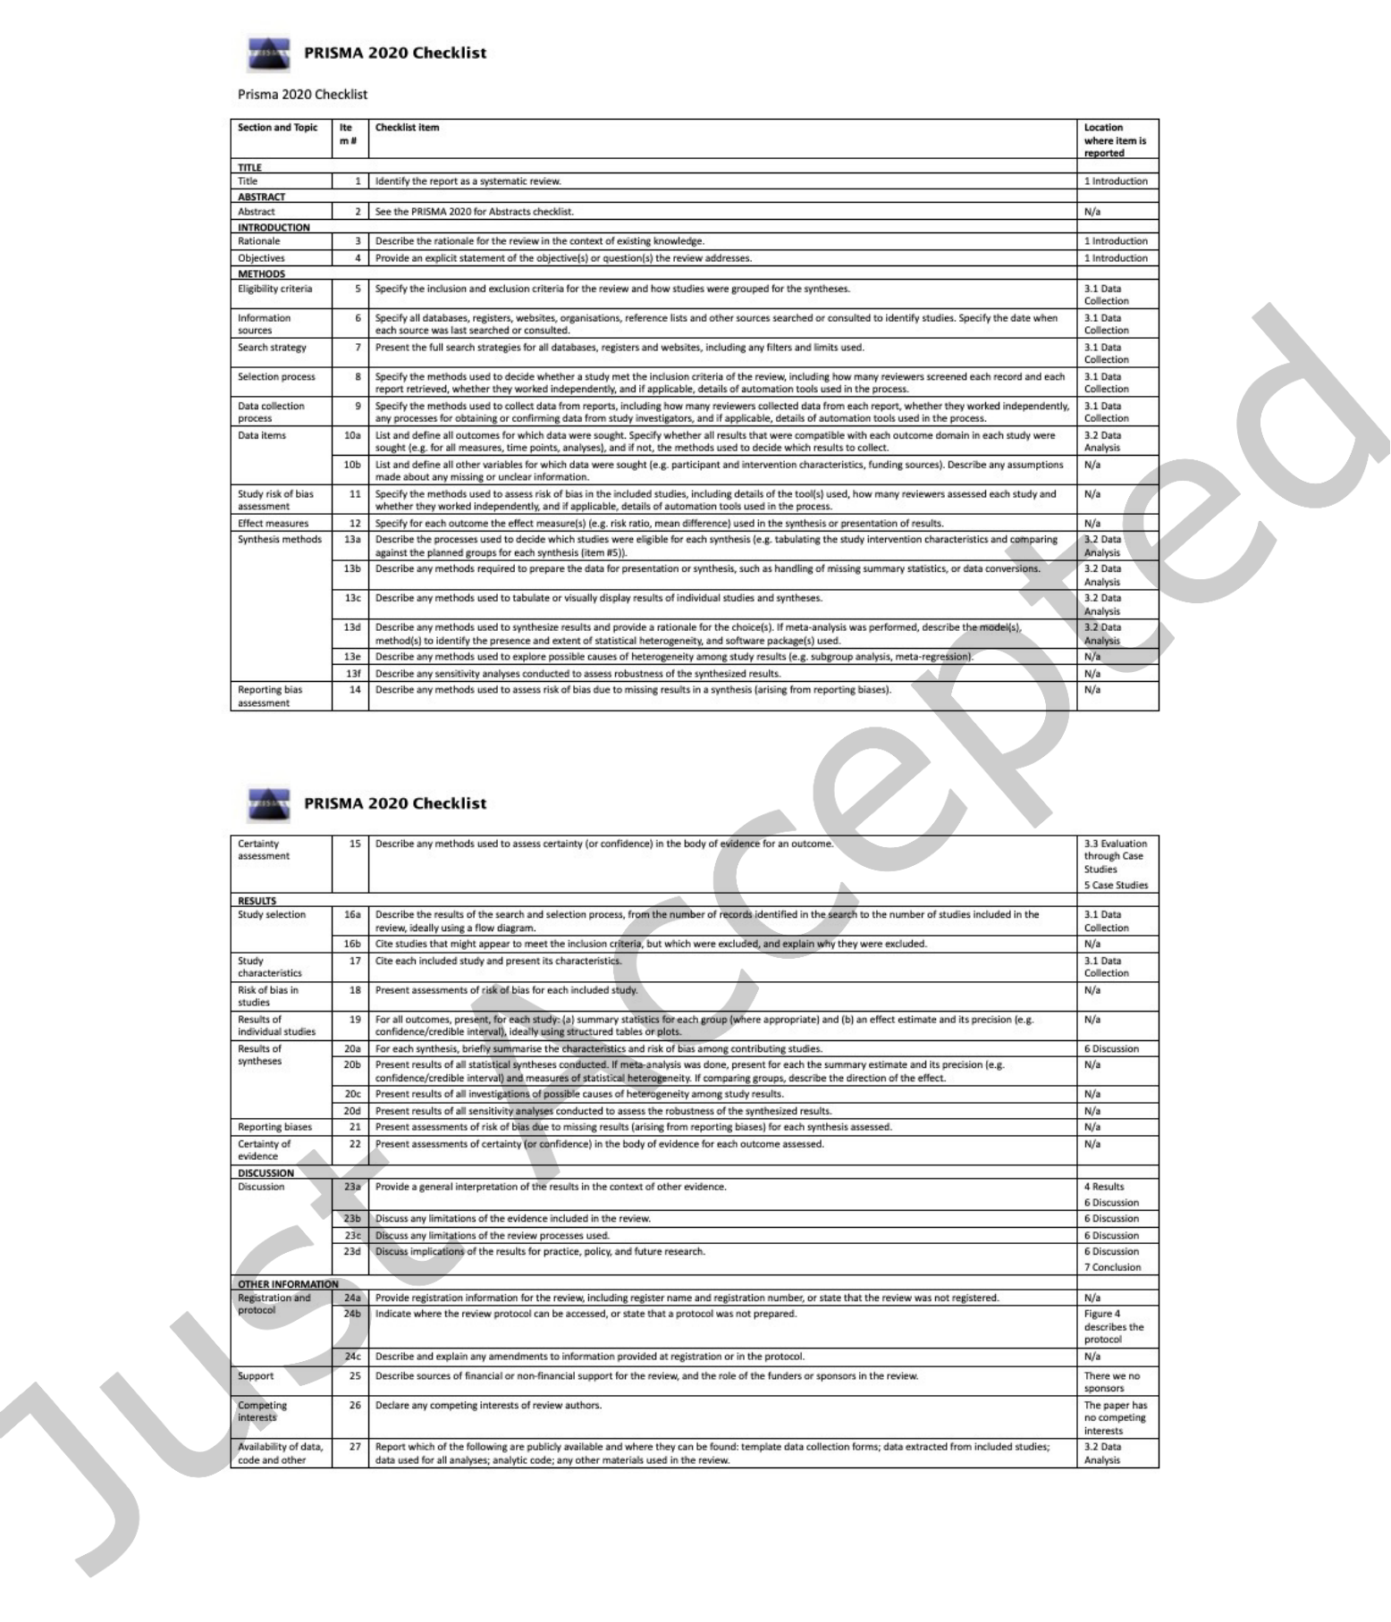

24 • Tamašauskait˙e and Groth

B PRISMA 2020 CHECKLIST

Fig. B.1. The PRISMA checklist for this review. From Page MJ, McKenzie JE, Bossuyt PM, Boutron I, Hofmann TC, Mulrow

CD, et al. The PRISMA 2020 statement: an updated guideline for reporting systematic reviews. BMJ 2021;372:n71. doi:

10.1136/bmj.n71 For more information, visit: <http://www.prisma-statement.org/>

C VISUALISATIONS OF THE KNOWLEDGE GRAPH DEVELOPMENT IN THE SELECTED ARTICLES

ACM Trans. Softw. Eng. Methodol., Vol. 1, No. 1, Article . Publication date: April 2022.

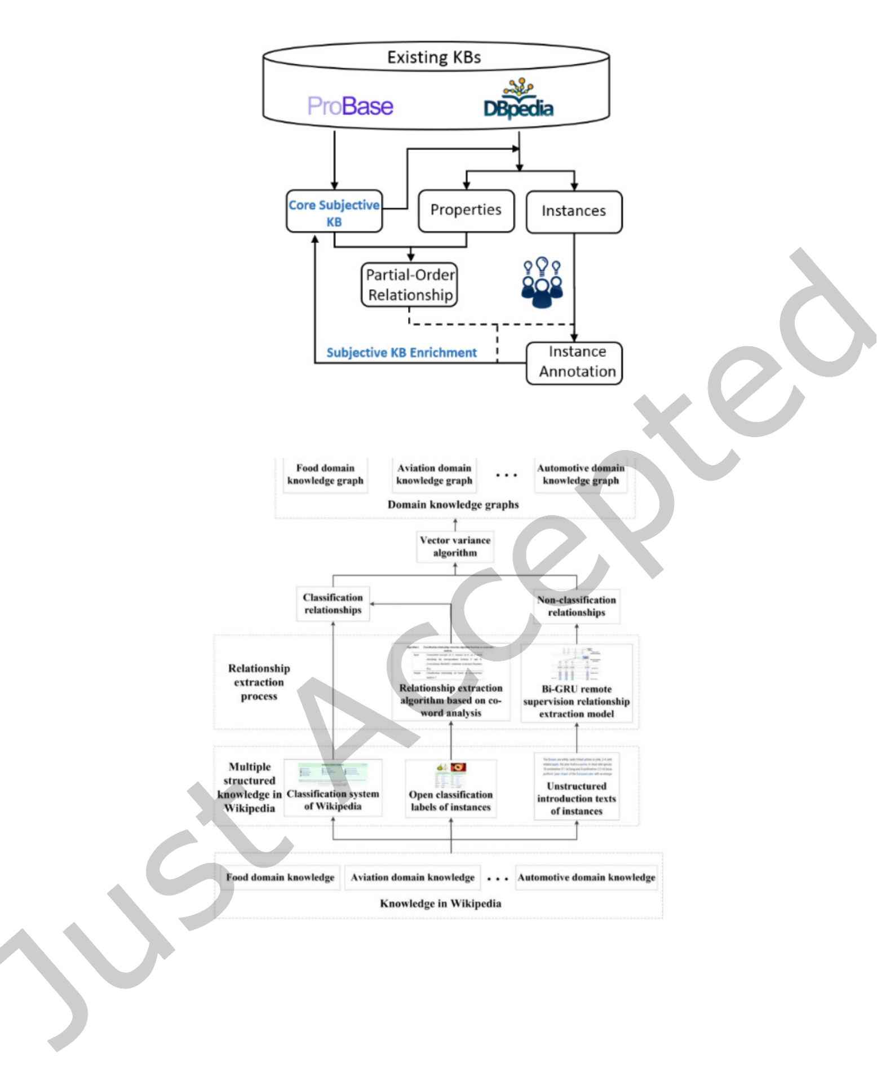

|  |  |  |
| --- | --- | --- |
| Defining a Knowledge Graph Development Process | • | 25 |

Fig. C.1. Workflow of subjective KB construction [85]

Fig. C.2. Framework of the construction method [88]

ACM Trans. Softw. Eng. Methodol., Vol. 1, No. 1, Article . Publication date: April 2022.

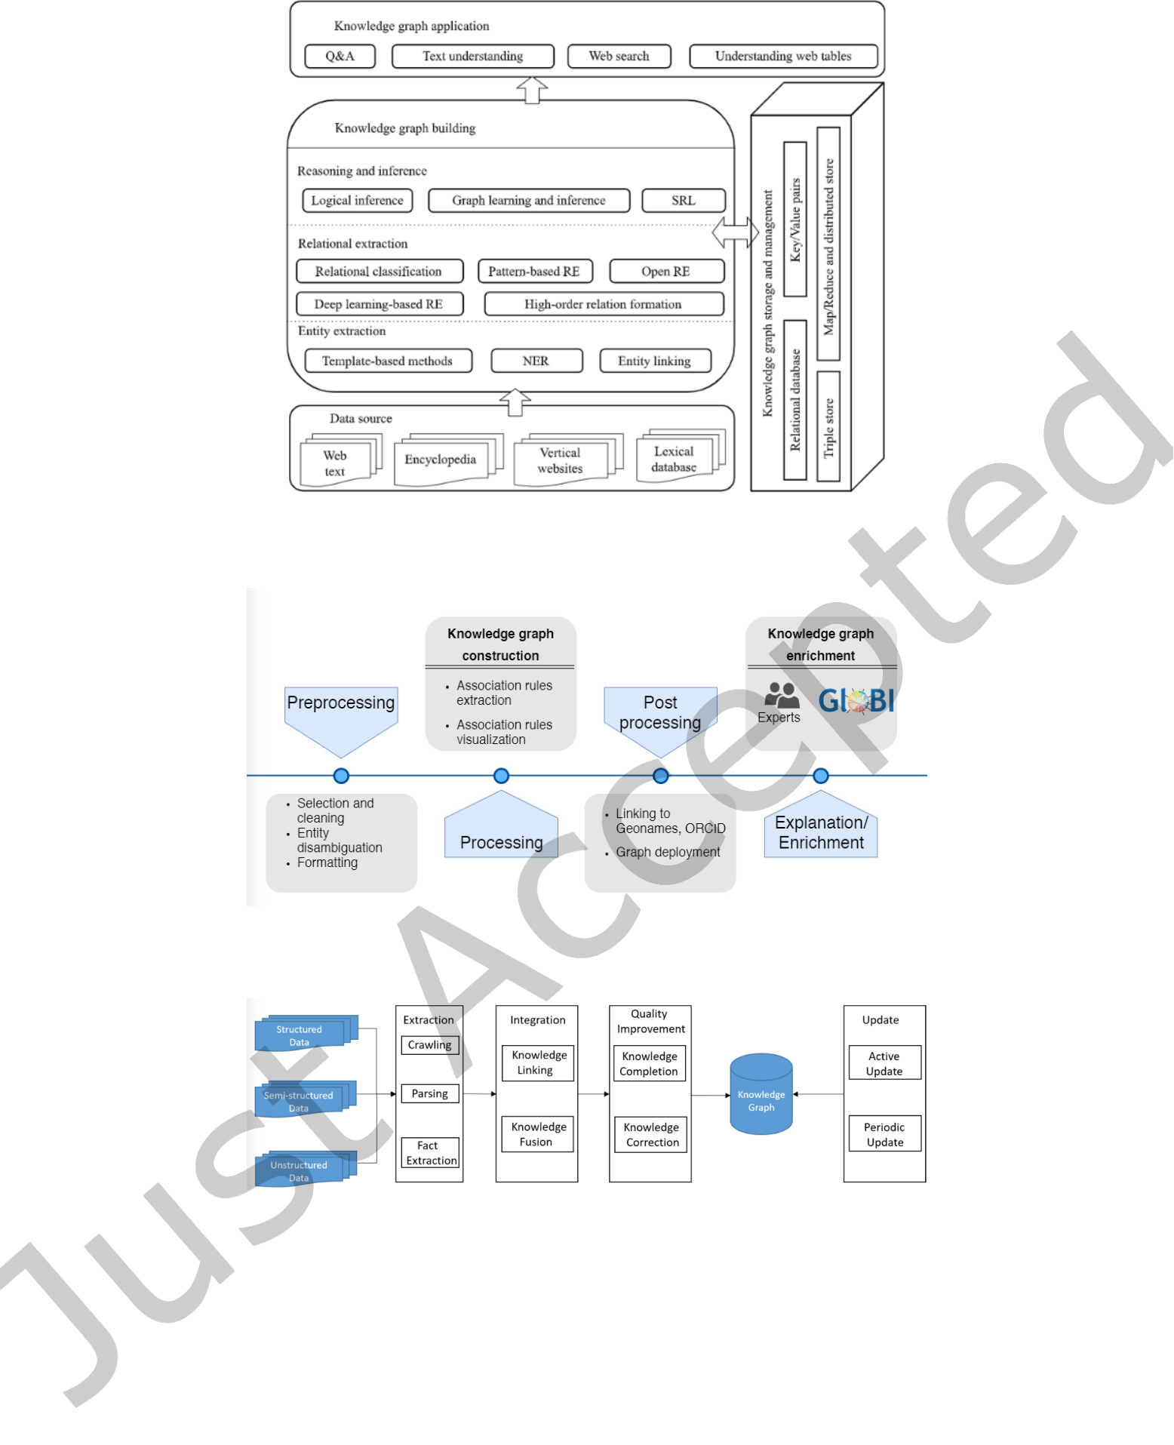

|  |  |  |
| --- | --- | --- |
| 26 | • | Tamašauskait˙e and Groth |

Fig. C.3. The framework of knowledge graph [87]

Fig. C.4. Data mining workflow for knowledge graph construction [65]

Fig. C.5. The general framework of Chinese knowledge graph construction [82]

ACM Trans. Softw. Eng. Methodol., Vol. 1, No. 1, Article . Publication date: April 2022.

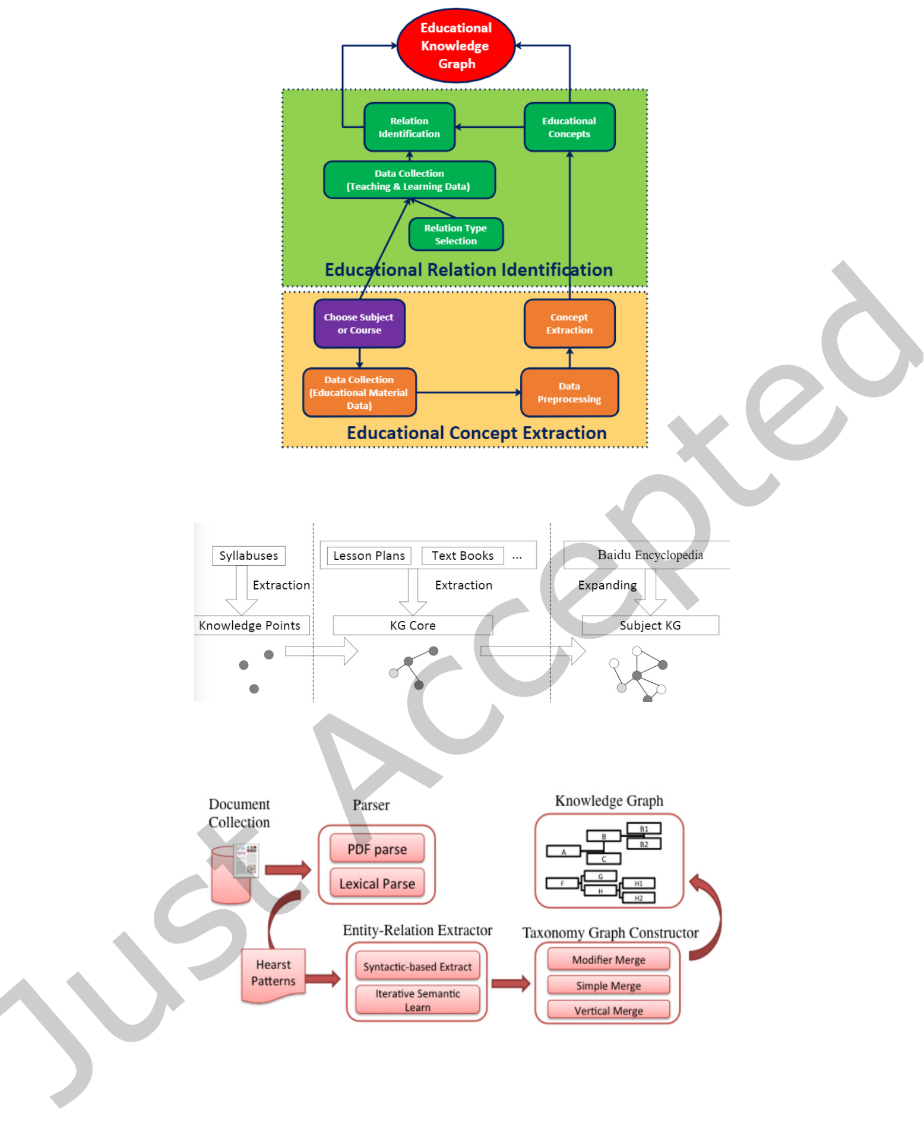

|  |  |  |
| --- | --- | --- |
| Defining a Knowledge Graph Development Process | • | 27 |

Fig. C.6. System architecture of K12EduKG [13]

Fig. C.7. The architecture of subject KG construction [67]

Fig. C.8. Knowledge base construction system [4]

ACM Trans. Softw. Eng. Methodol., Vol. 1, No. 1, Article . Publication date: April 2022.

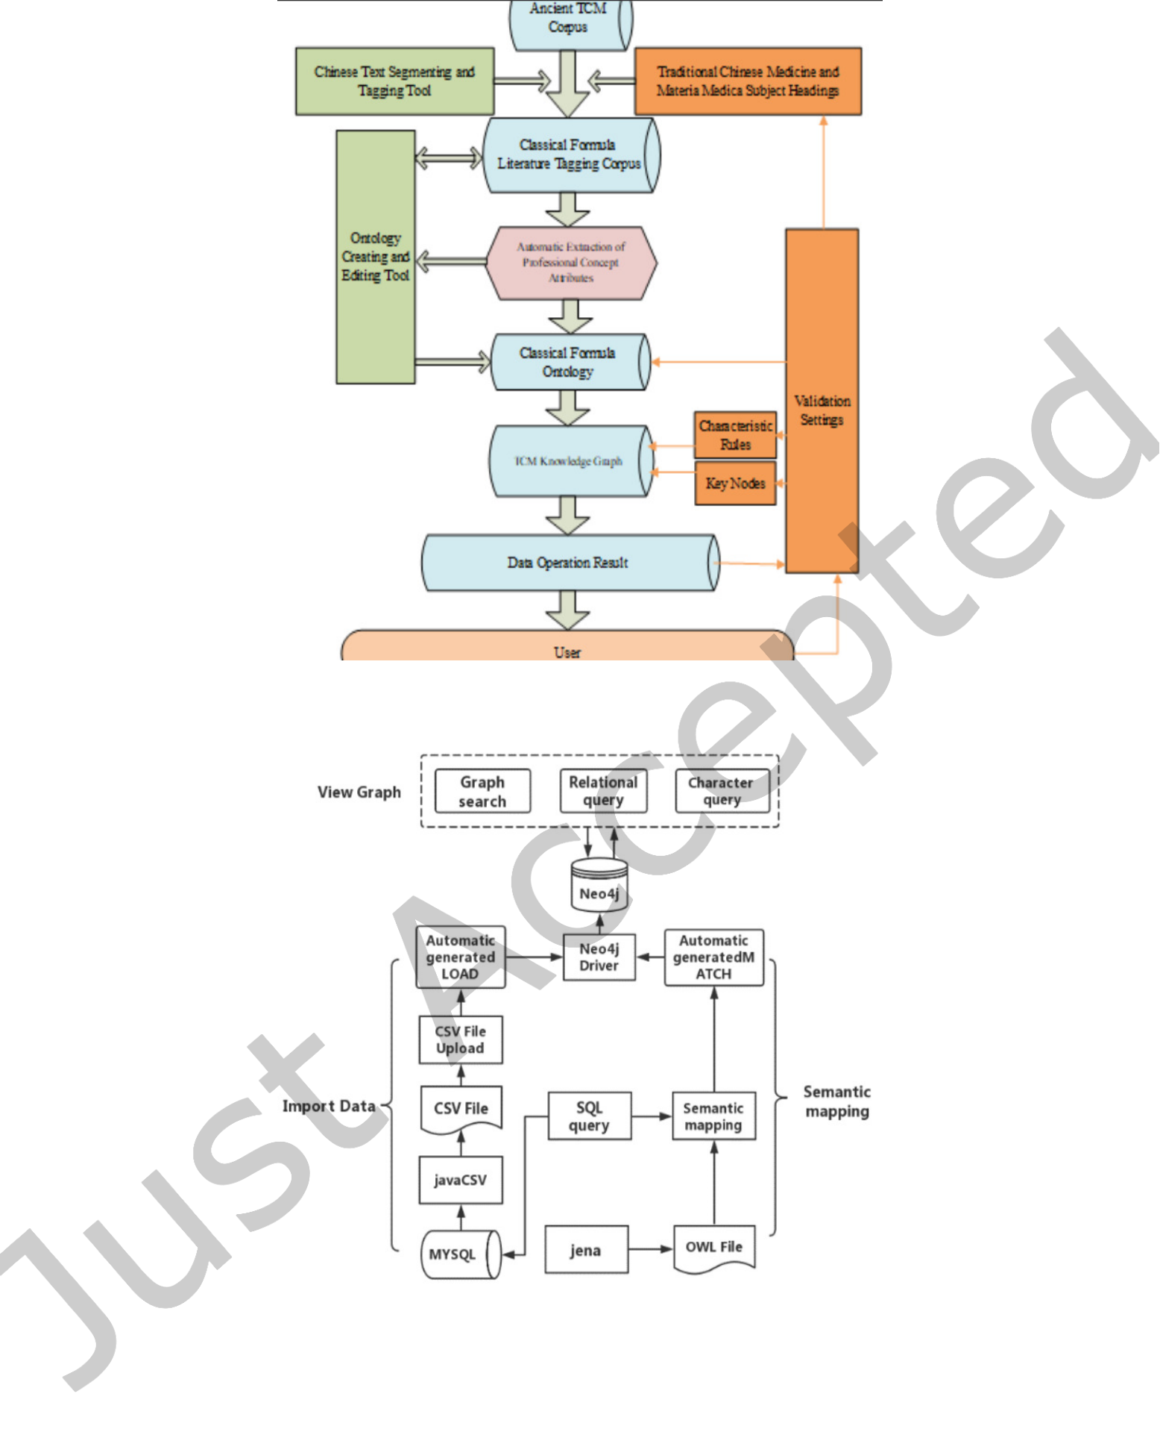

|  |  |  |
| --- | --- | --- |
| 28 | • | Tamašauskait˙e and Groth |

Fig. C.9. The overall framework of TCM knowledge graph construction [94]

Fig. C.10. Functional design framework [33]

ACM Trans. Softw. Eng. Methodol., Vol. 1, No. 1, Article . Publication date: April 2022.

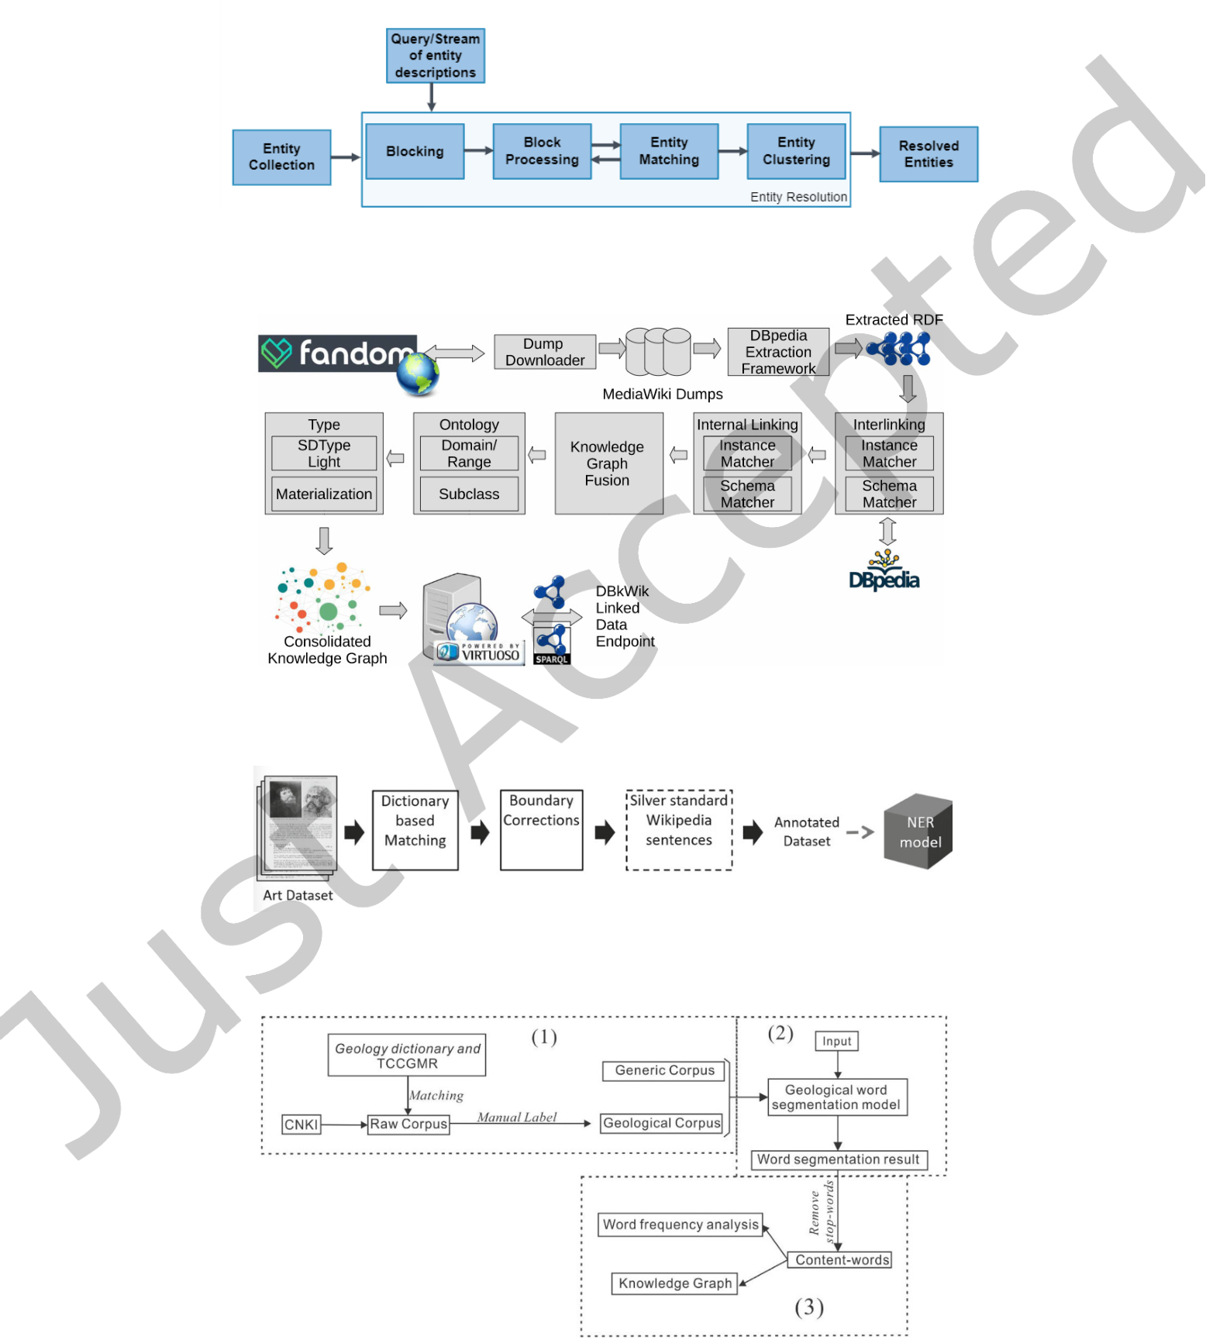

|  |  |  |
| --- | --- | --- |
| Defining a Knowledge Graph Development Process | • | 29 |

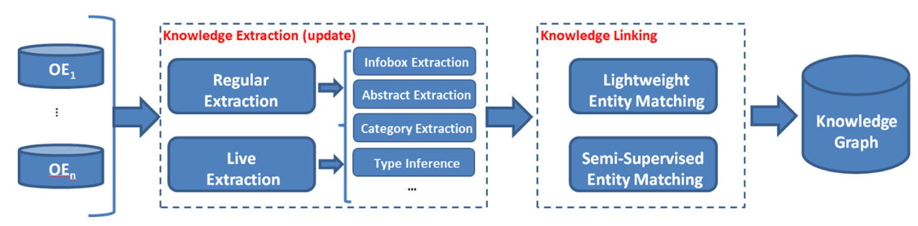

Fig. C.11. Proposed framework (OE:Online encyclopedia) [83]

Fig. C.12. The generic end-to-end workflow for Entity Resolution [17]

Fig. C.13. The overall workflow creating the DBkWik knowledge graph [28]

Fig. C.14. First approach for NER for artwork titles [36]

Fig. C.15. Technique procedure in this study [75]

ACM Trans. Softw. Eng. Methodol., Vol. 1, No. 1, Article . Publication date: April 2022.

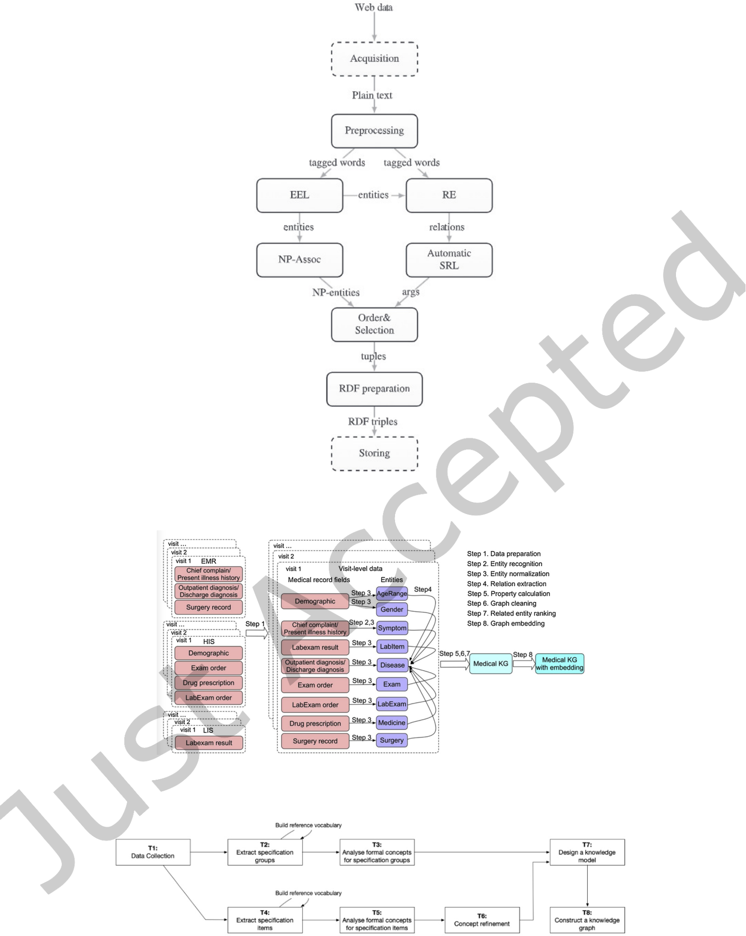

|  |  |  |
| --- | --- | --- |
| 30 | • | Tamašauskait˙e and Groth |

Fig. C.16. Overview of the proposed method [54]

Fig. C.17. Proposed systematic procedure of medical KG construction [47]

Fig. C.18. Overall process of analyzing formal concepts from collected specifications and transforming a product knowledge

graph [41]

ACM Trans. Softw. Eng. Methodol., Vol. 1, No. 1, Article . Publication date: April 2022.

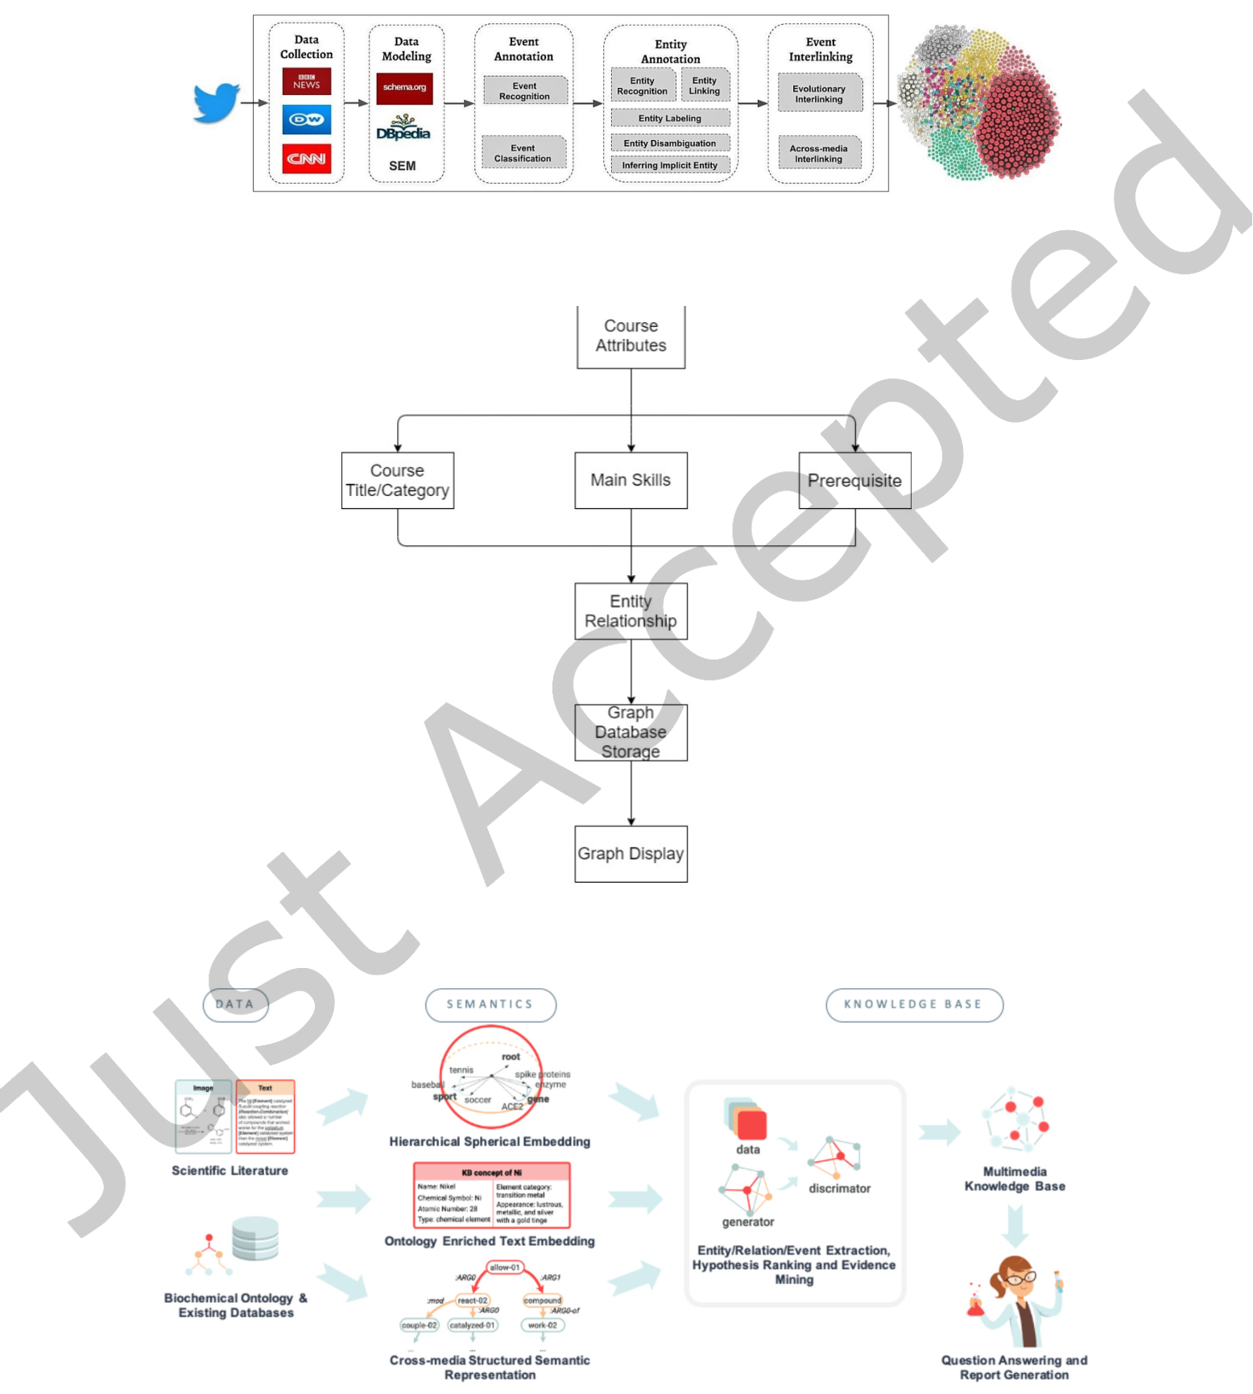

|  |  |  |
| --- | --- | --- |
| Defining a Knowledge Graph Development Process | • | 31 |

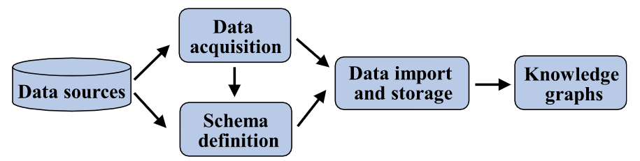

Fig. C.19. Construction process of the knowledge graph [53]

Fig. C.20. The pipeline of the required steps for developing a knowledge graph of interlined events [66]

Fig. C.21. The process of creating this knowledge graph [90]

Fig. C.22. COVID-KG overview: from data to semantics to knowledge [78]

ACM Trans. Softw. Eng. Methodol., Vol. 1, No. 1, Article . Publication date: April 2022.

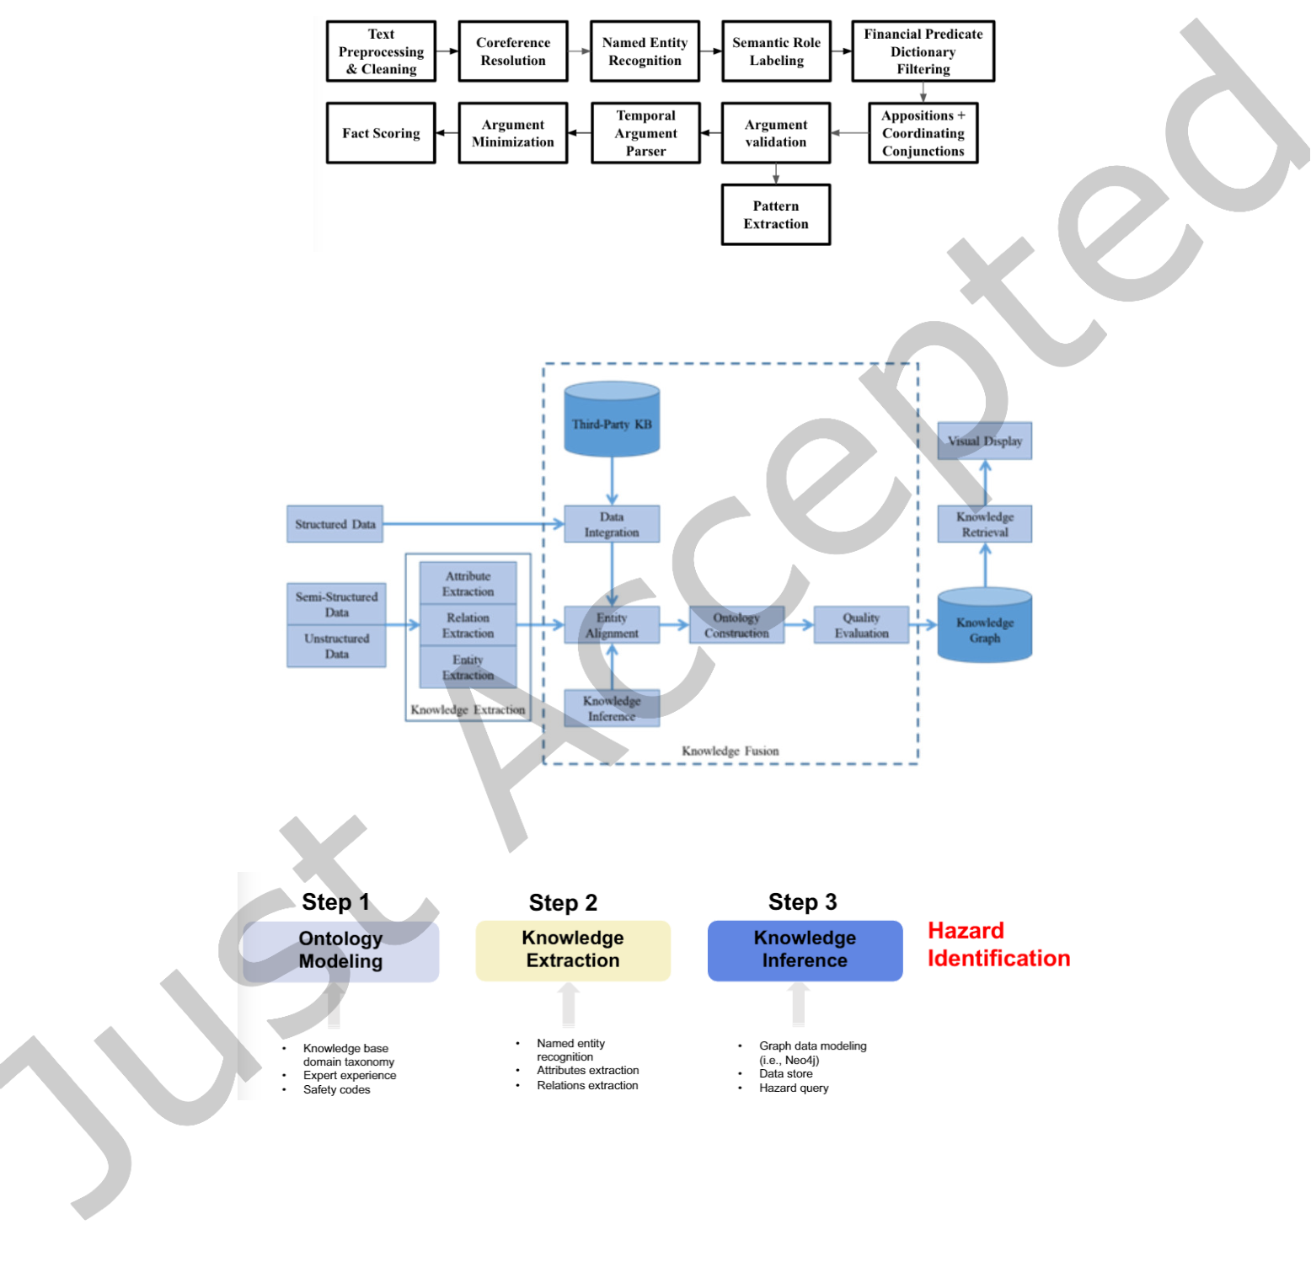

|  |  |  |
| --- | --- | --- |
| 32 | • | Tamašauskait˙e and Groth |

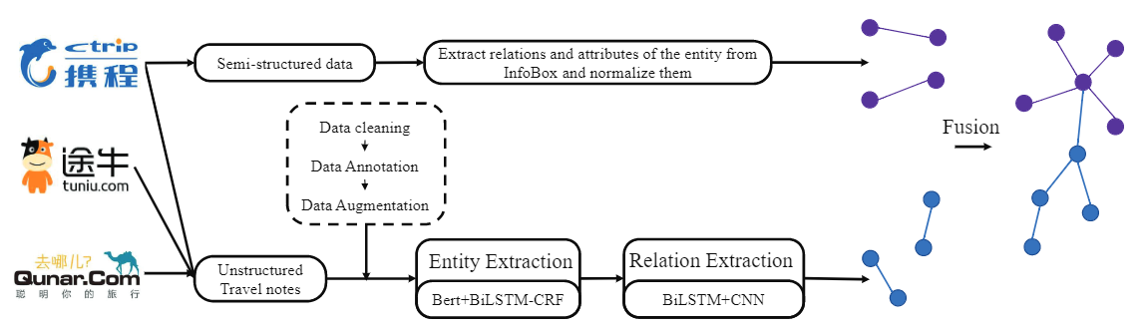

Fig. C.23. The overview of our method [84]

Fig. C.24. The financial knowledge extraction pipeline [21]

Fig. C.25. The architecture of knowledge graph [92]

Fig. C.26. The workflow of the proposed hybrid semantic computer vision approach [22]

ACM Trans. Softw. Eng. Methodol., Vol. 1, No. 1, Article . Publication date: April 2022.

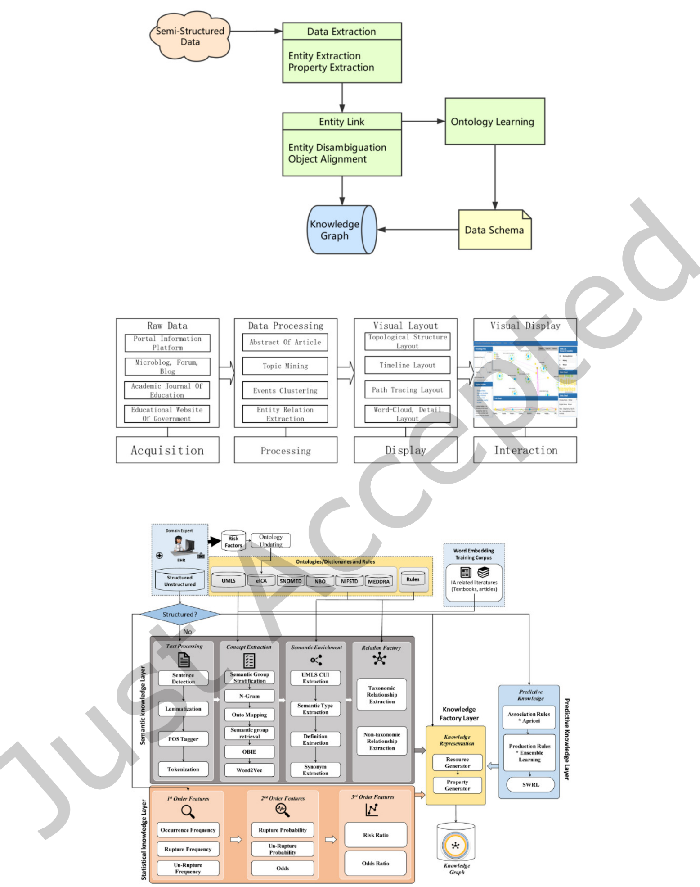

|  |  |  |
| --- | --- | --- |
| Defining a Knowledge Graph Development Process | • | 33 |

Fig. C.27. Building a knowledge graph flowchart [16]

Fig. C.28. Constructing process of the visual analysis platform [69]

Fig. C.29. Functional view of automated knowledge graph architecture [52]

ACM Trans. Softw. Eng. Methodol., Vol. 1, No. 1, Article . Publication date: April 2022.

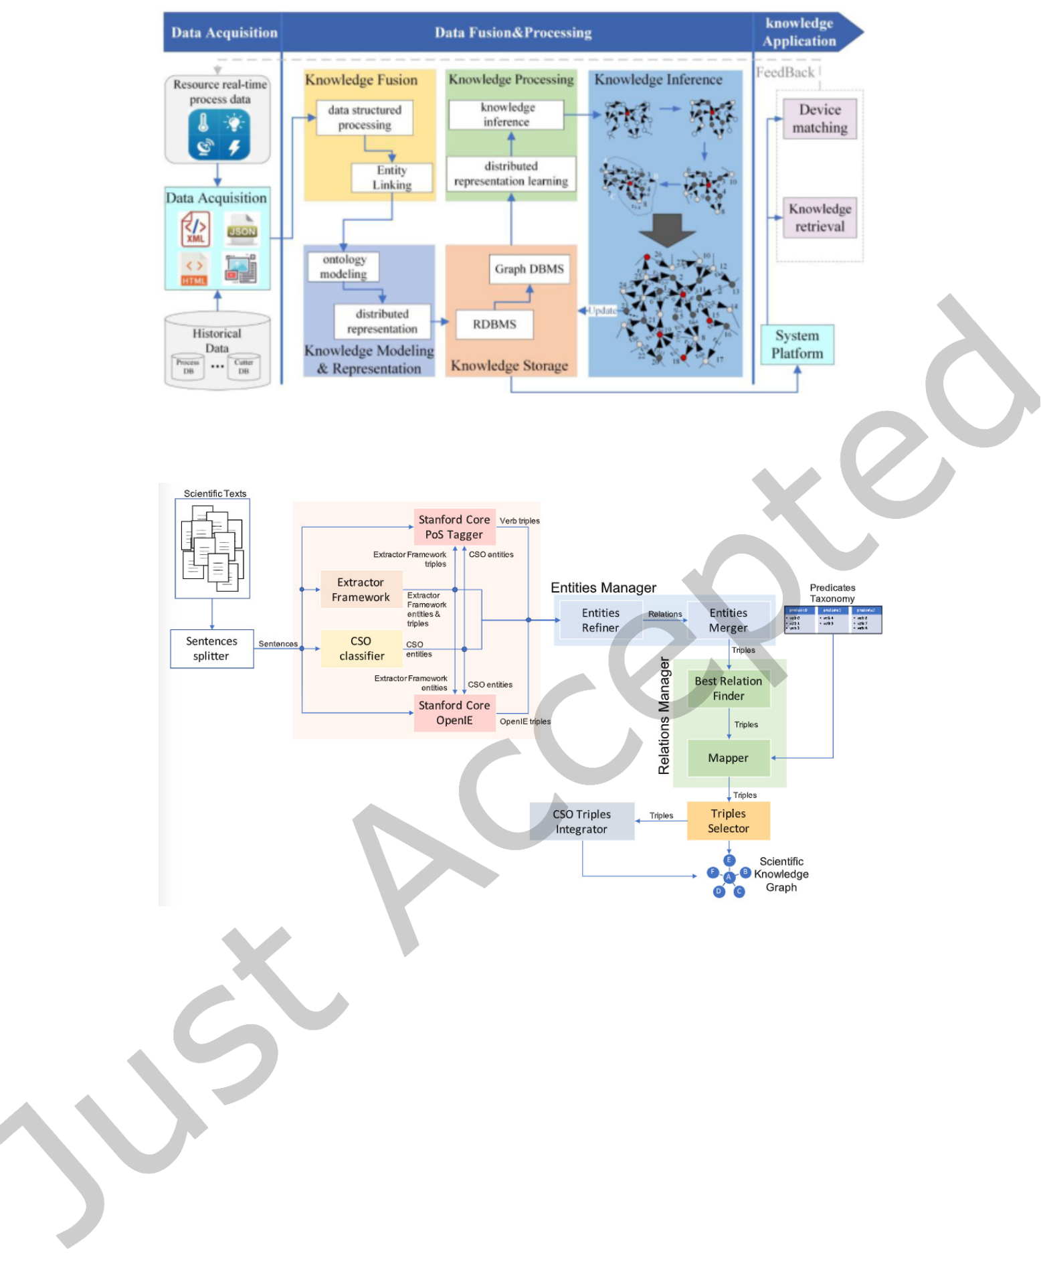

|  |  |  |
| --- | --- | --- |
| 34 | • | Tamašauskait˙e and Groth |

Fig. C.30. The framework for construction for WRKG [93]

Fig. C.31. Workflow of the approach for building a scientific knowledge graph from scientific textual resources [18]

ACM Trans. Softw. Eng. Methodol., Vol. 1, No. 1, Article . Publication date: April 2022.

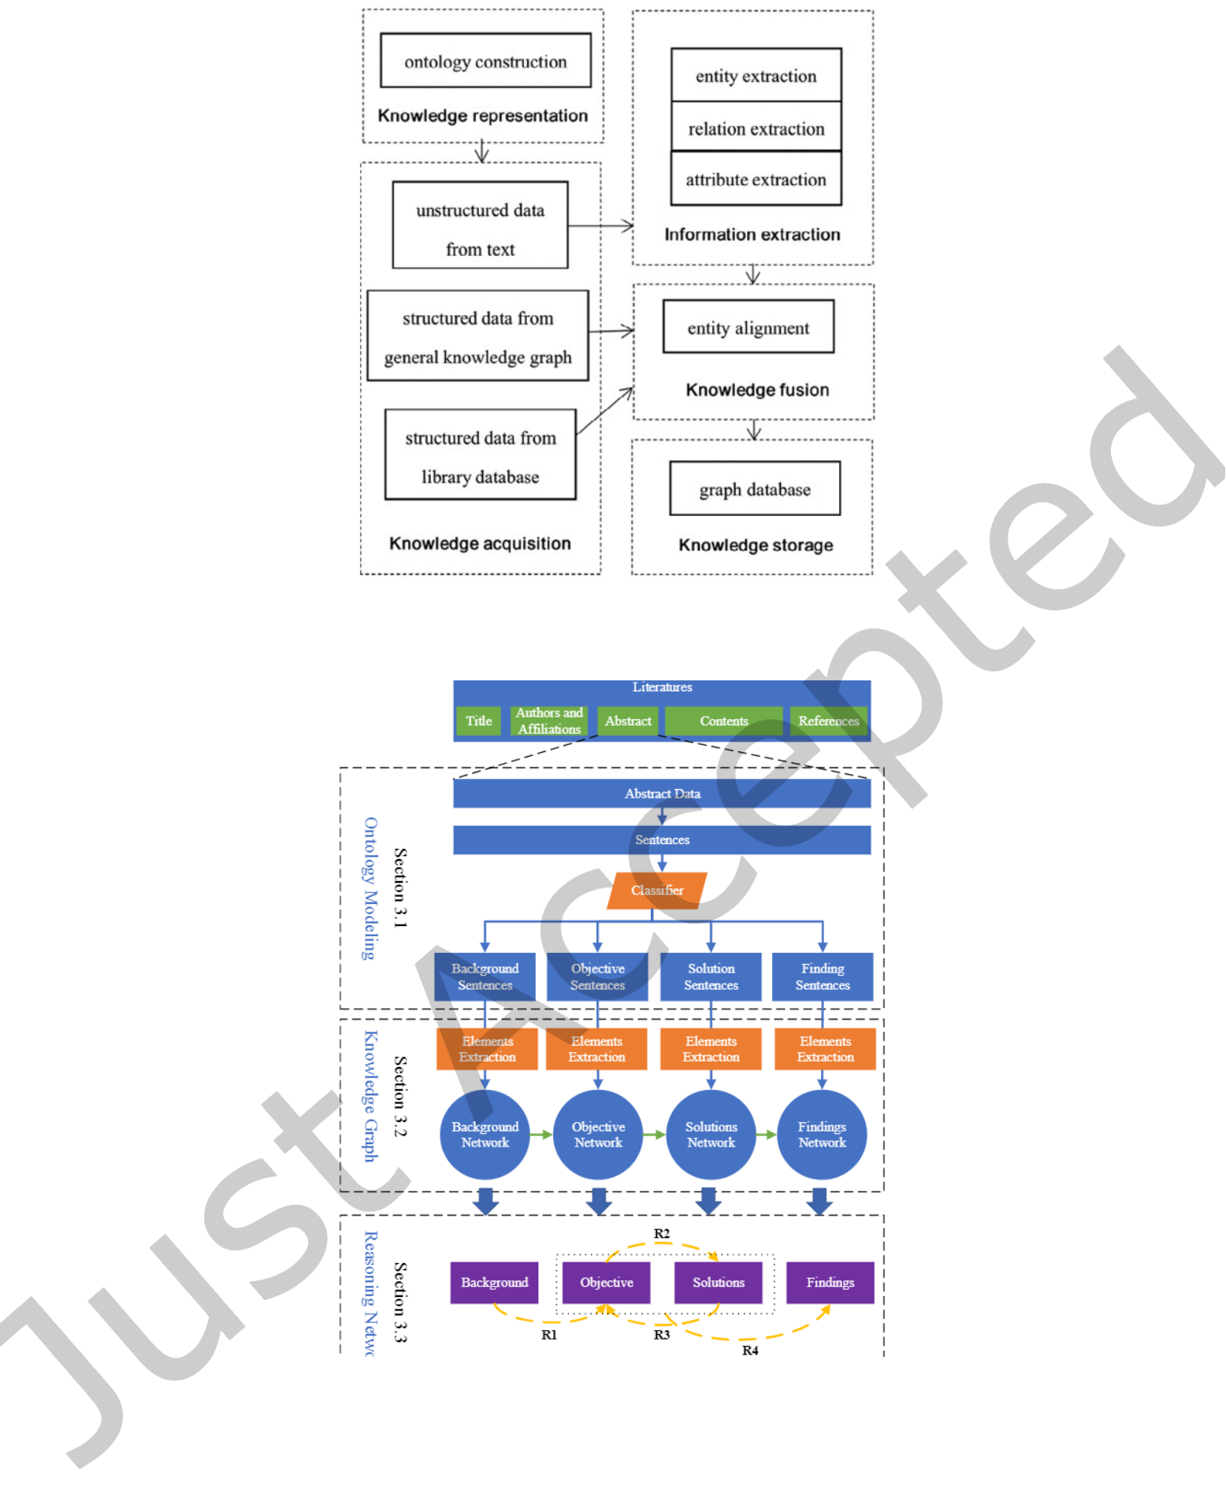

|  |  |  |
| --- | --- | --- |
| Defining a Knowledge Graph Development Process | • | 35 |

Fig. C.32. The flowchart of knowledge graph in the domain of culture [79]

Fig. C.33. The three-level framework of the ontology-based literatures’ knowledge reasoning network modeling [12]

ACM Trans. Softw. Eng. Methodol., Vol. 1, No. 1, Article . Publication date: April 2022.

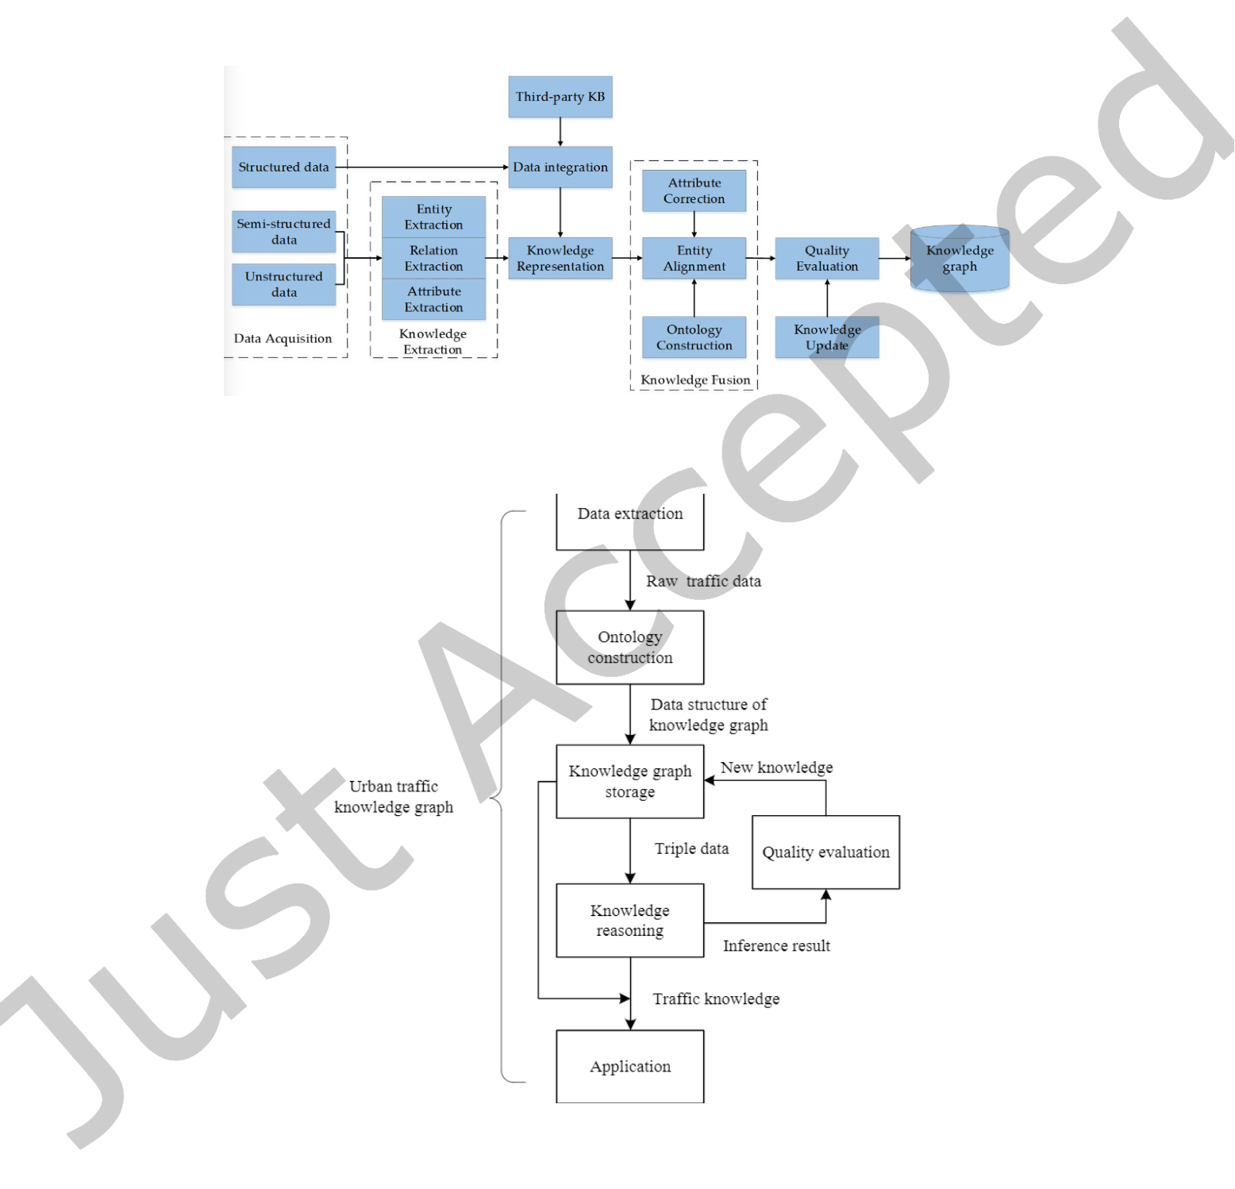

|  |  |  |
| --- | --- | --- |
| 36 | • | Tamašauskait˙e and Groth |

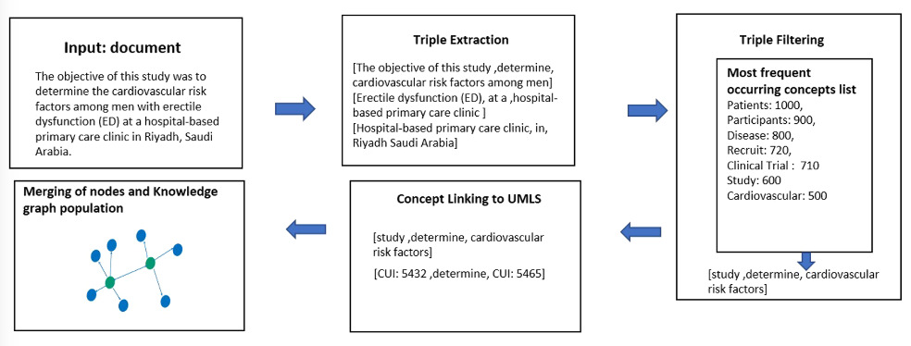

Fig. C.34. Stages involved in the construction of a literature knowledge graph using OIE4KGC [56]

Fig. C.35. Construction framework of Chinese ancient historical and cultural knowledge graph [51]

Fig. C.36. Research framework for the construction and complement of knowledge graphs in the field of urban trafic [70]

ACM Trans. Softw. Eng. Methodol., Vol. 1, No. 1, Article . Publication date: April 2022.

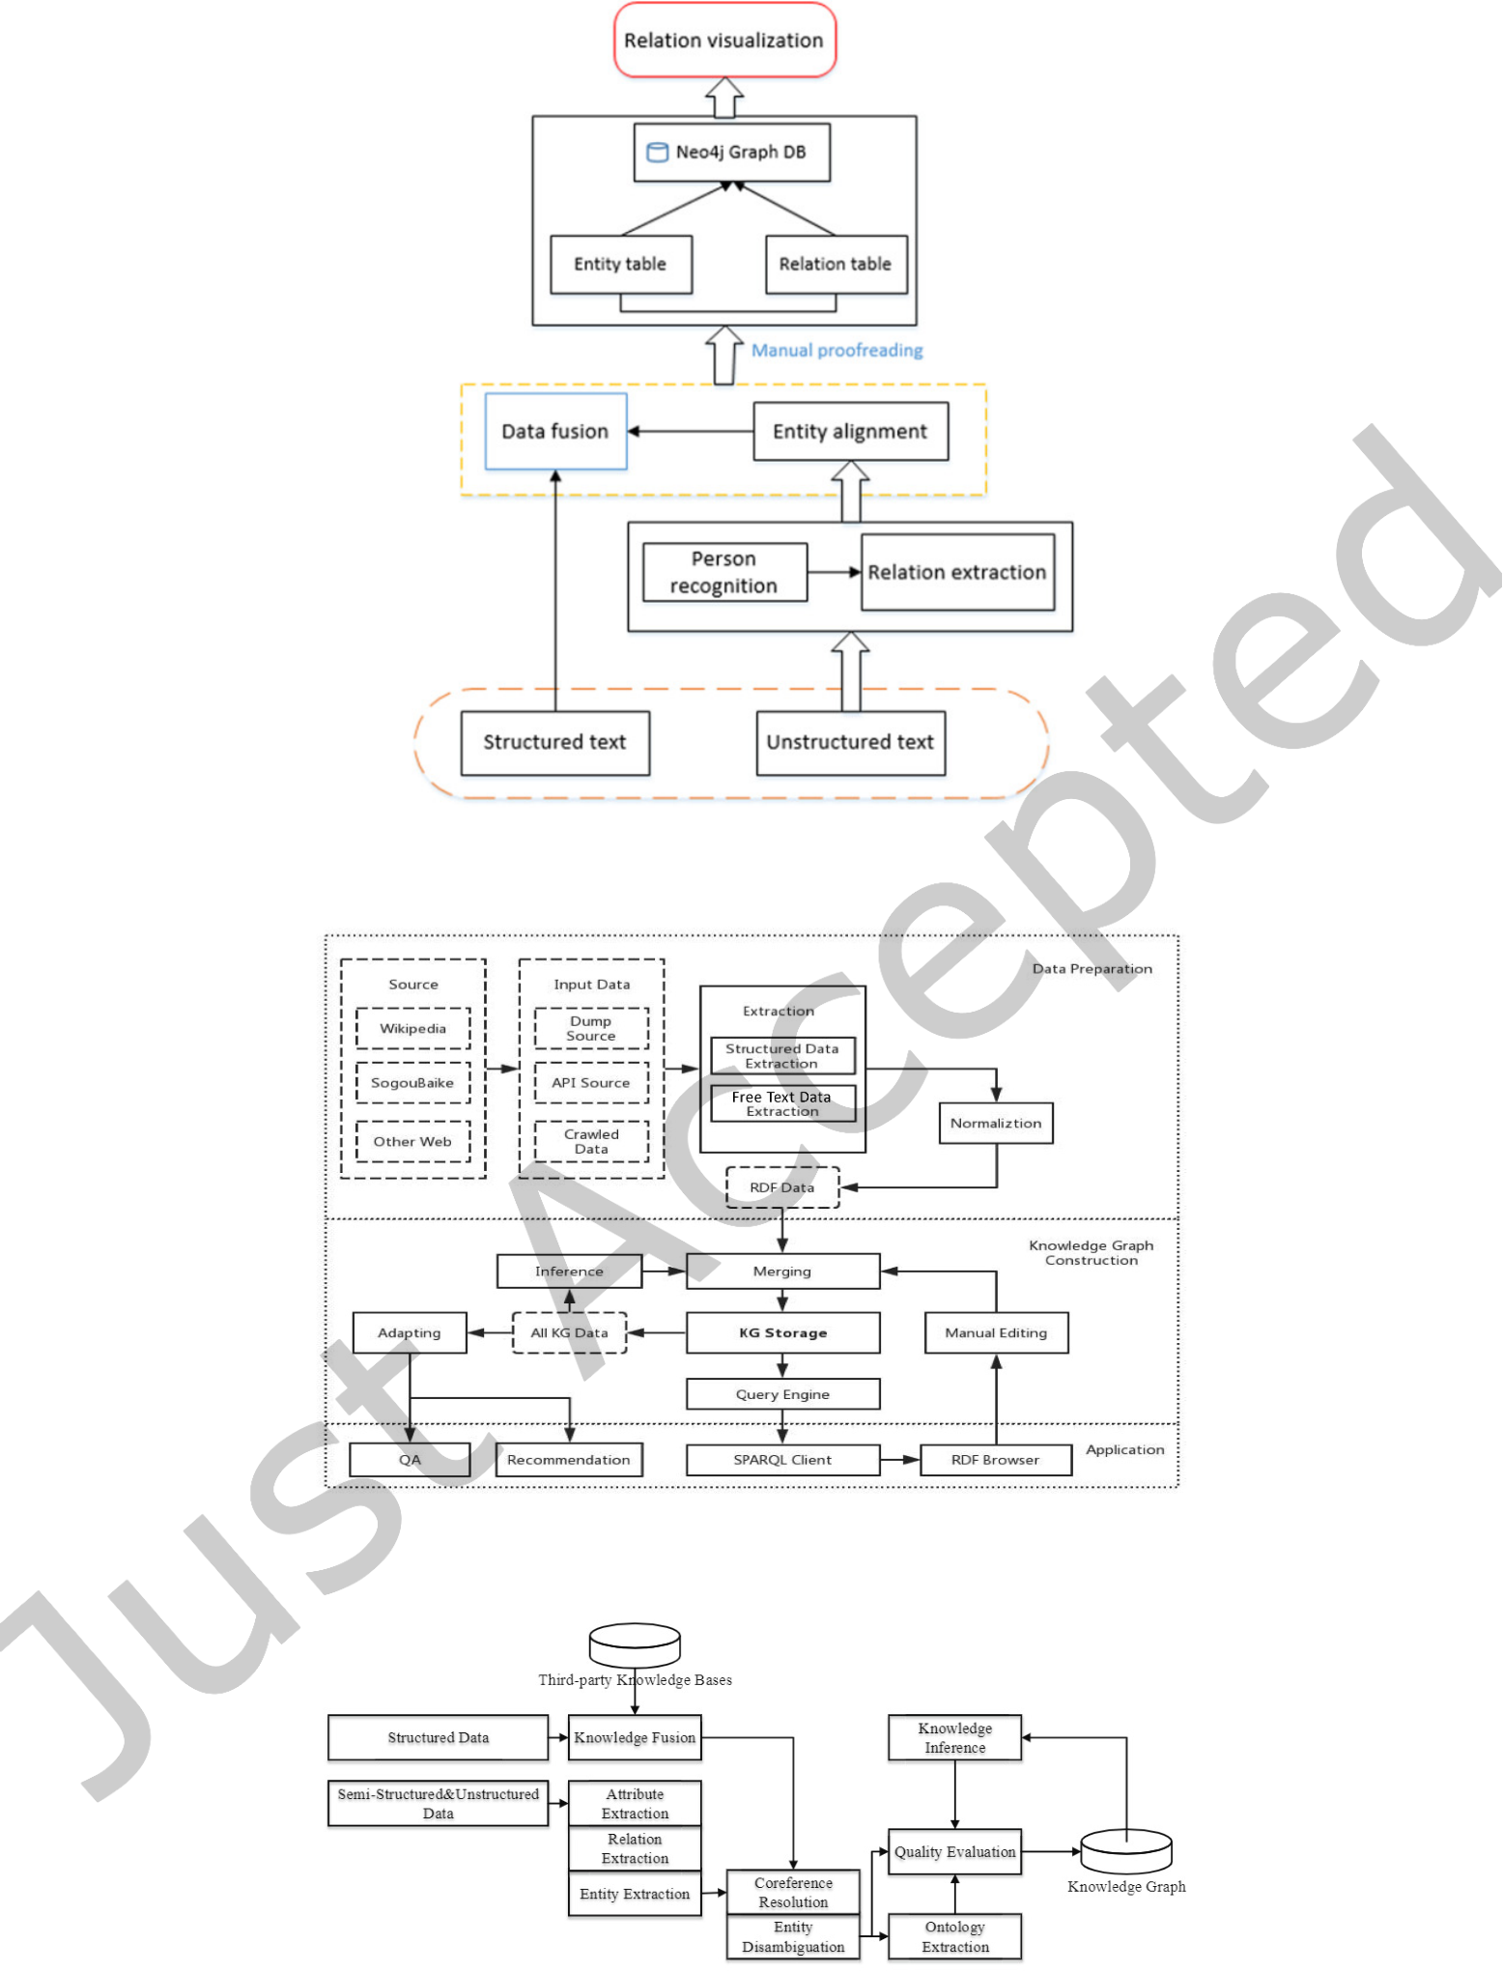

|  |  |  |
| --- | --- | --- |
| Defining a Knowledge Graph Development Process | • | 37 |

Fig. C.37. The united process to construct the graph personal relationships [38]

Fig. C.38. Overview of Sogou knowledge graph construction framework [77]

Fig. C.39. The process of knowledge graph construction [48]

ACM Trans. Softw. Eng. Methodol., Vol. 1, No. 1, Article . Publication date: April 2022.

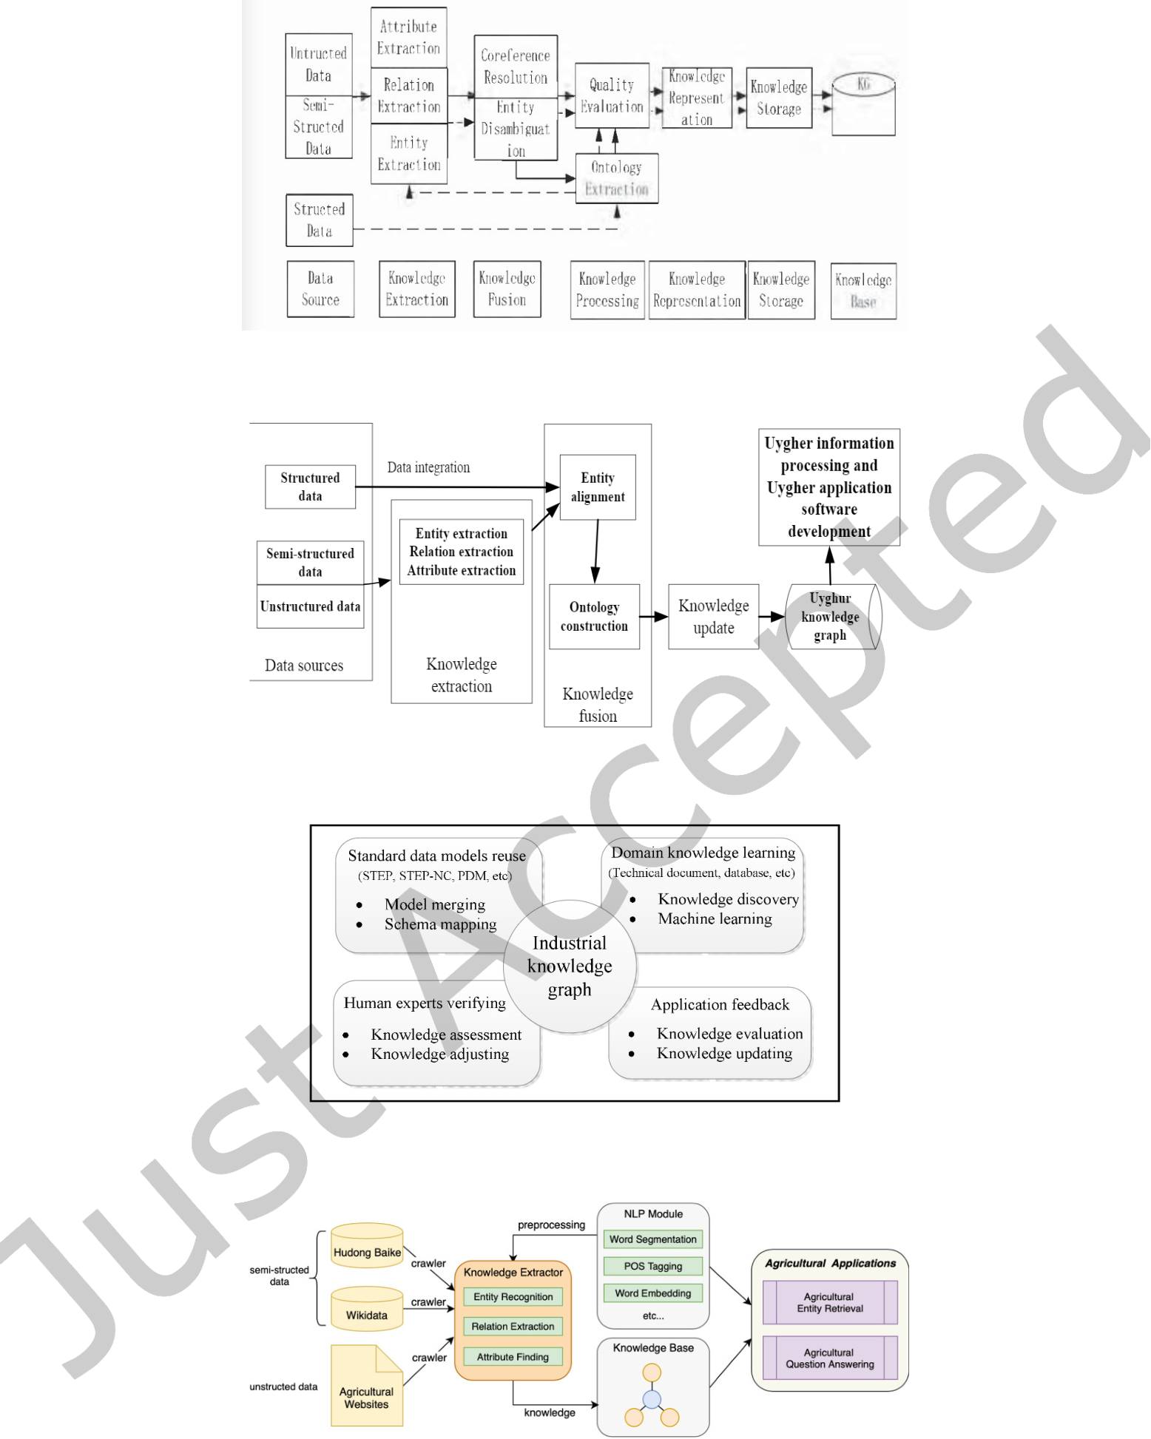

|  |  |  |
| --- | --- | --- |
| 38 | • | Tamašauskait˙e and Groth |

Fig. C.40. Improved flow chart of knowledge graph construction [45]

Fig. C.41. The process of constructing Uyghur knowledge graph [62]

Fig. C.42. Collaborative development of industrial knowledge graph [91]

Fig. C.43. The framework of AgriKG [14]

ACM Trans. Softw. Eng. Methodol., Vol. 1, No. 1, Article . Publication date: April 2022.

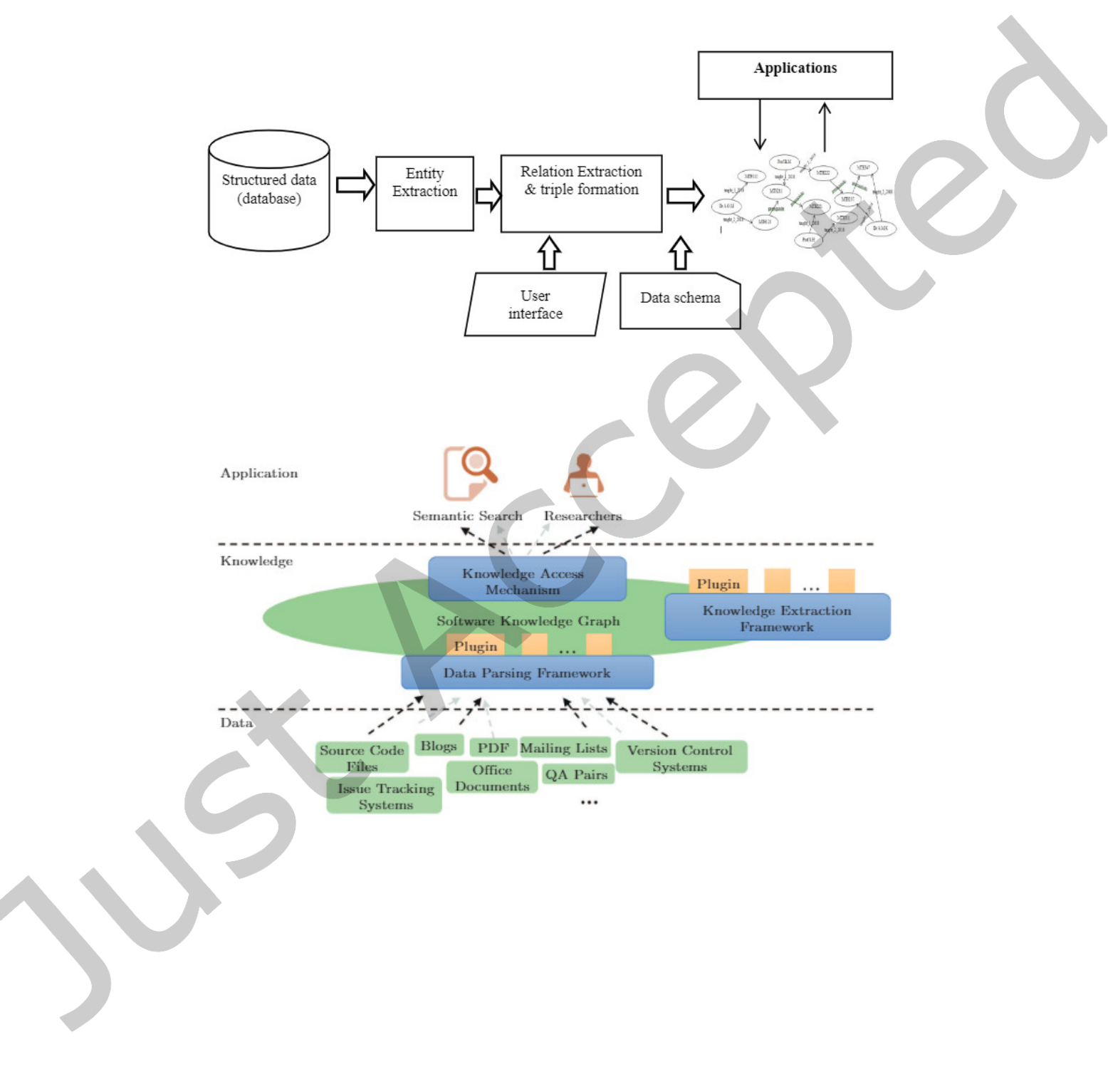

|  |  |  |
| --- | --- | --- |
| Defining a Knowledge Graph Development Process | • | 39 |

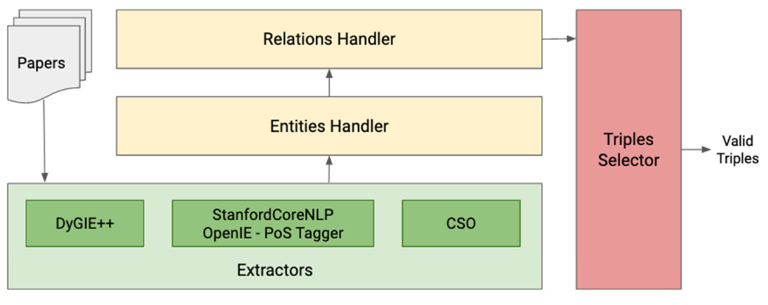

Fig. C.44. Schema of the pipeline to extract and handle entities and relations [19]

Fig. C.45. System architecture [6]

Fig. C.46. Logical overview of the sotware knowledge graph construction platform [49]

ACM Trans. Softw. Eng. Methodol., Vol. 1, No. 1, Article . Publication date: April 2022.

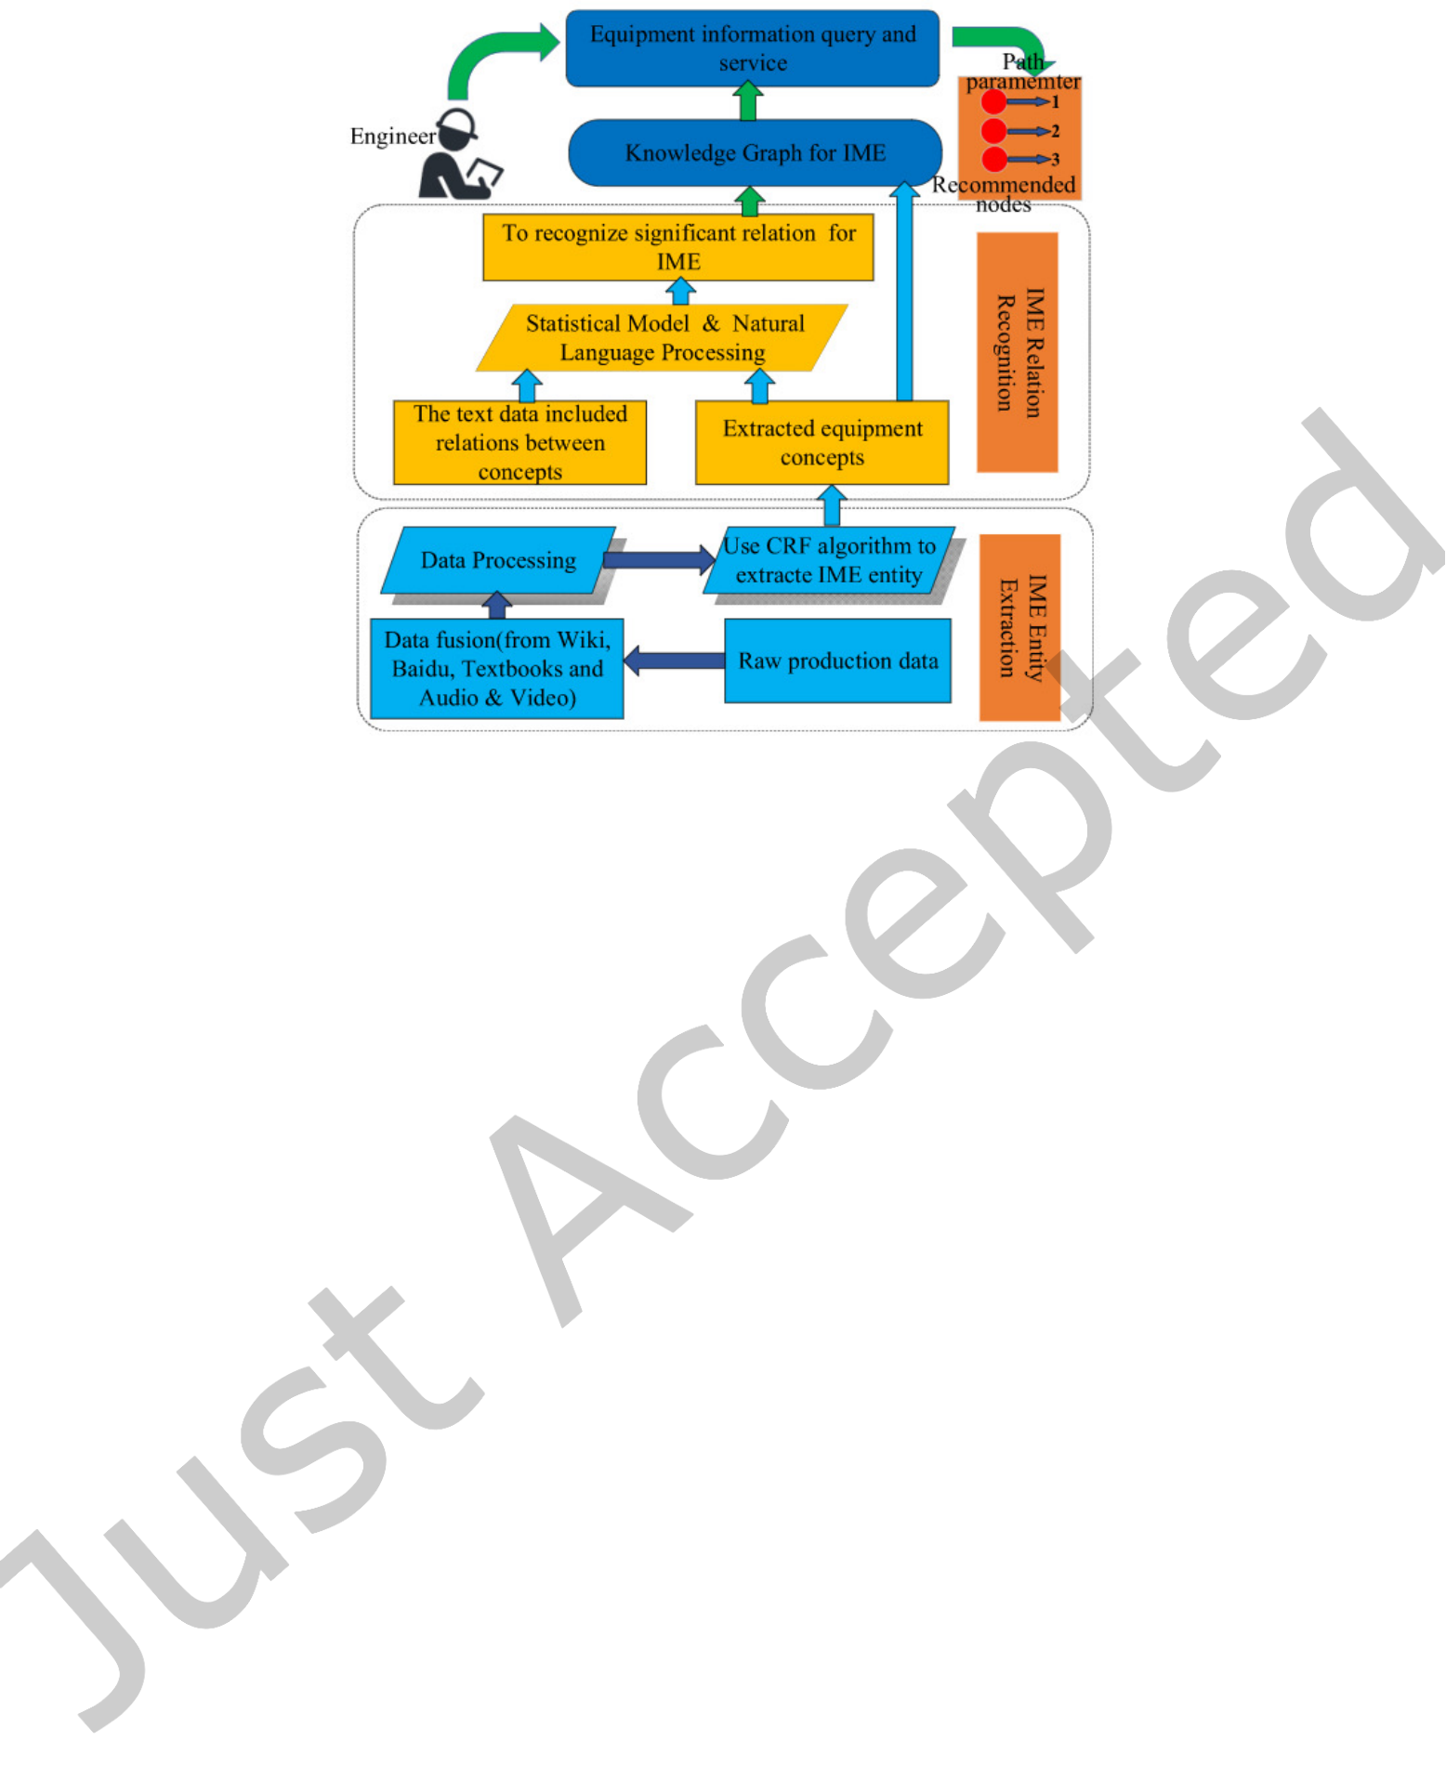

|  |  |  |
| --- | --- | --- |
| 40 | • | Tamašauskait˙e and Groth |

Fig. C.47. The process of built knowledge graph [86]

ACM Trans. Softw. Eng. Methodol., Vol. 1, No. 1, Article . Publication date: April 2022.